`

Yasir Shahzad@DESKTOP-CARCG87 MINGW64 /f/VisualStudioCode/Class1

$ pwd

/f/VisualStudioCode/Class1

Yasir Shahzad@DESKTOP-CARCG87 MINGW64 /f/VisualStudioCode/Class1

$ ls

Yasir Shahzad@DESKTOP-CARCG87 MINGW64 /f/VisualStudioCode/Class1

$ mrkdir images

bash: mrkdir: command not found

Yasir Shahzad@DESKTOP-CARCG87 MINGW64 /f/VisualStudioCode/Class1

$ mkdir images:

Yasir Shahzad@DESKTOP-CARCG87 MINGW64 /f/VisualStudioCode/Class1

$ clear

____________________________________________________________________________________________________________________

Yasir Shahzad@DESKTOP-CARCG87 MINGW64 /f/VisualStudioCode/Class1

$ pwd

/f/VisualStudioCode/Class1

Yasir Shahzad@DESKTOP-CARCG87 MINGW64 /f/VisualStudioCode/Class1

$ pwd

/f/VisualStudioCode/Class1

Yasir Shahzad@DESKTOP-CARCG87 MINGW64 /f/VisualStudioCode/Class1

$ ls

images:/

Yasir Shahzad@DESKTOP-CARCG87 MINGW64 /f/VisualStudioCode/Class1

$ mkdir css html bootsrip javascript

Yasir Shahzad@DESKTOP-CARCG87 MINGW64 /f/VisualStudioCode/Class1

$ ls

bootsrip/ css/ html/ images:/ javascript/

Yasir Shahzad@DESKTOP-CARCG87 MINGW64 /f/VisualStudioCode/Class1

$

______________________________________________________________________________________________________________

Yasir Shahzad@DESKTOP-CARCG87 MINGW64 /f/VisualStudioCode/Class1

$ pwd

/f/VisualStudioCode/Class1

Yasir Shahzad@DESKTOP-CARCG87 MINGW64 /f/VisualStudioCode/Class1

$ pwd

/f/VisualStudioCode/Class1

Yasir Shahzad@DESKTOP-CARCG87 MINGW64 /f/VisualStudioCode/Class1

$ ls

images:/

Yasir Shahzad@DESKTOP-CARCG87 MINGW64 /f/VisualStudioCode/Class1

$ mkdir css html bootsrip javascript

Yasir Shahzad@DESKTOP-CARCG87 MINGW64 /f/VisualStudioCode/Class1

$ ls

bootsrip/ css/ html/ images:/ javascript/

Yasir Shahzad@DESKTOP-CARCG87 MINGW64 /f/VisualStudioCode/Class1

$ pwd

/f/VisualStudioCode/Class1

Yasir Shahzad@DESKTOP-CARCG87 MINGW64 /f/VisualStudioCode/Class1

$ cd c:

Yasir Shahzad@DESKTOP-CARCG87 MINGW64 /c

$ ls

'$Recycle.Bin'/ 'Documents and Settings'@ hiberfil.sys pagefile.sys 'Program Files (x86)'/ swapfile.sys Users/

'$WinREAgent'/ DumpStack.log Intel/ PerfLogs/ ProgramData/ 'System Volume Information'/ Windows/

Chrone/ DumpStack.log.tmp MSOCache/ 'Program Files'/ Recovery/ TypingMaster11/

Yasir Shahzad@DESKTOP-CARCG87 MINGW64 /c

$

________________________________________________________________________________

Yasir Shahzad@DESKTOP-CARCG87 MINGW64 /c

$ cd i:

bash: cd: i:: No such file or directory

Yasir Shahzad@DESKTOP-CARCG87 MINGW64 /c

$ cd e:

Yasir Shahzad@DESKTOP-CARCG87 MINGW64 /e

$ ls

'$RECYCLE.BIN'/

'[FreeCourseSite.com] Udemy - Android O & Java - The Complete Android Development Bootcamp'/

'~$Aqib.docx'

'~$llet surf account code and other information.docx'

20170520_0901/

Aaqib.pdf

Aqib.docx

aqib.pdf

'Asir Shahzad decoment'/

Books/

'BS Computer Science'/

Camera/

'Computer Parograme'/

'Cv style'/

EstateAgency/

'General knowledge about name'/

'How To FIX-Repair A Corrupted USB Flash Drive or SD Card Urdu- Hindi Tutorial.mp4'

'lahore tour'/

'Program with yaseen'/

'System Volume Information'/

'Treasure of knowledge 3rd Edition_compressed.pdf'

'Wallet surf account code and other information.docx'

'Yasir Camera'/

'Yasir Personal Folder'/

'Yasir Shahzad'/

'Yasir Shahzad and his life.docx'

Yasir Shahzad@DESKTOP-CARCG87 MINGW64 /e

$

__________________________________________________________________________________________

Yasir Shahzad@DESKTOP-CARCG87 MINGW64 /f/VisualStudioCode/Class1

$ pwd

/f/VisualStudioCode/Class1

Yasir Shahzad@DESKTOP-CARCG87 MINGW64 /f/VisualStudioCode/Class1

$ pwd

/f/VisualStudioCode/Class1

Yasir Shahzad@DESKTOP-CARCG87 MINGW64 /f/VisualStudioCode/Class1

$ ls

images:/

Yasir Shahzad@DESKTOP-CARCG87 MINGW64 /f/VisualStudioCode/Class1

$ mkdir css html bootsrip javascript

Yasir Shahzad@DESKTOP-CARCG87 MINGW64 /f/VisualStudioCode/Class1

$ ls

bootsrip/ css/ html/ images:/ javascript/

Yasir Shahzad@DESKTOP-CARCG87 MINGW64 /f/VisualStudioCode/Class1

$ pwd

/f/VisualStudioCode/Class1

Yasir Shahzad@DESKTOP-CARCG87 MINGW64 /f/VisualStudioCode/Class1

$ cd c:

Yasir Shahzad@DESKTOP-CARCG87 MINGW64 /c

$ ls

'$Recycle.Bin'/ 'Documents and Settings'@ hiberfil.sys pagefile.sys 'Program Files (x86)'/ swapfile.sys Users/

'$WinREAgent'/ DumpStack.log Intel/ PerfLogs/ ProgramData/ 'System Volume Information'/ Windows/

Chrone/ DumpStack.log.tmp MSOCache/ 'Program Files'/ Recovery/ TypingMaster11/

Yasir Shahzad@DESKTOP-CARCG87 MINGW64 /c

$ pwd

/c

Yasir Shahzad@DESKTOP-CARCG87 MINGW64 /c

$ cd i:

bash: cd: i:: No such file or directory

Yasir Shahzad@DESKTOP-CARCG87 MINGW64 /c

$ cd e:

Yasir Shahzad@DESKTOP-CARCG87 MINGW64 /e

$ ls

'$RECYCLE.BIN'/

'[FreeCourseSite.com] Udemy - Android O & Java - The Complete Android Development Bootcamp'/

'~$Aqib.docx'

'~$llet surf account code and other information.docx'

20170520_0901/

Aaqib.pdf

Aqib.docx

aqib.pdf

'Asir Shahzad decoment'/

Books/

'BS Computer Science'/

Camera/

'Computer Parograme'/

'Cv style'/

EstateAgency/

'General knowledge about name'/

'How To FIX-Repair A Corrupted USB Flash Drive or SD Card Urdu- Hindi Tutorial.mp4'

'lahore tour'/

'Program with yaseen'/

'System Volume Information'/

'Treasure of knowledge 3rd Edition_compressed.pdf'

Yasir Shahzad@DESKTOP-CARCG87 MINGW64 /

$ pwd

/

Yasir Shahzad@DESKTOP-CARCG87 MINGW64 /

$ cd f:

Yasir Shahzad@DESKTOP-CARCG87 MINGW64 /f

$ ls

'$RECYCLE.BIN'/ '12 oct 2022'/ EstateAgency/ 'Programming courses'/

'~$esis final.docx' 'Baseer photostate'/ 'Hozaifa Computer'/ 'System Volume Information'/

'~$w Microsoft Word Document.docx' 'Chief Sahib'/ 'New Microsoft Word Document.docx' VisualStudioCode/

Yasir Shahzad@DESKTOP-CARCG87 MINGW64 /f

$ cd

cd cdd.dll cdosys.dll cdp.dll cdprt.dll cdpsvc.dll cdpusersvc.dll

Yasir Shahzad@DESKTOP-CARCG87 MINGW64 /f

$ cd

Yasir Shahzad@DESKTOP-CARCG87 MINGW64 ~

$ cd visualStudioCode

bash: cd: visualStudioCode: No such file or directory

Yasir Shahzad@DESKTOP-CARCG87 MINGW64 ~

$ cd f:

Yasir Shahzad@DESKTOP-CARCG87 MINGW64 /f

$ ld

bash: ld: command not found

Yasir Shahzad@DESKTOP-CARCG87 MINGW64 /f

$ ls

'$RECYCLE.BIN'/ '12 oct 2022'/ EstateAgency/ 'Programming courses'/

'~$esis final.docx' 'Baseer photostate'/ 'Hozaifa Computer'/ 'System Volume Information'/

'~$w Microsoft Word Document.docx' 'Chief Sahib'/ 'New Microsoft Word Document.docx' VisualStudioCode/

Yasir Shahzad@DESKTOP-CARCG87 MINGW64 /f

$ cd .gitfetch

bash: cd: .gitfetch: No such file or directory

Yasir Shahzad@DESKTOP-CARCG87 MINGW64 /f

$ cd. visualstudiocode

bash: cd.: command not found

Yasir Shahzad@DESKTOP-CARCG87 MINGW64 /f

$ cd f:

Yasir Shahzad@DESKTOP-CARCG87 MINGW64 /f

$ cd VisualStudioCode/

Yasir Shahzad@DESKTOP-CARCG87 MINGW64 /f/VisualStudioCode

$ ls

Class1/

Yasir Shahzad@DESKTOP-CARCG87 MINGW64 /f/VisualStudioCode

$ ls

Class1/

Yasir Shahzad@DESKTOP-CARCG87 MINGW64 /f/VisualStudioCode

$ cd Class1/

Yasir Shahzad@DESKTOP-CARCG87 MINGW64 /f/VisualStudioCode/Class1

$ ls

bootsrip/ css/ html/ images:/ javascript/

Yasir Shahzad@DESKTOP-CARCG87 MINGW64 /f/VisualStudioCode/Class1

$ cd html/

Yasir Shahzad@DESKTOP-CARCG87 MINGW64 /f/VisualStudioCode/Class1/html

$

___________________________________________________________________________________

Yasir Shahzad@DESKTOP-CARCG87 MINGW64 /f

$ cd f:

Yasir Shahzad@DESKTOP-CARCG87 MINGW64 /f

$ cd VisualStudioCode/

Yasir Shahzad@DESKTOP-CARCG87 MINGW64 /f/VisualStudioCode

$ ls

Class1/

Yasir Shahzad@DESKTOP-CARCG87 MINGW64 /f/VisualStudioCode

$ ls

Class1/

Yasir Shahzad@DESKTOP-CARCG87 MINGW64 /f/VisualStudioCode

$ cd Class1/

Yasir Shahzad@DESKTOP-CARCG87 MINGW64 /f/VisualStudioCode/Class1

$ ls

bootsrip/ css/ html/ images:/ javascript/

Yasir Shahzad@DESKTOP-CARCG87 MINGW64 /f/VisualStudioCode/Class1

$ cd html/

Yasir Shahzad@DESKTOP-CARCG87 MINGW64 /f/VisualStudioCode/Class1/html

$ cd ..

Yasir Shahzad@DESKTOP-CARCG87 MINGW64 /f/VisualStudioCode/Class1

$ cd..

bash: cd..: command not found

Yasir Shahzad@DESKTOP-CARCG87 MINGW64 /f/VisualStudioCode/Class1

$ cd ..

Yasir Shahzad@DESKTOP-CARCG87 MINGW64 /f/VisualStudioCode

$ cd Class1/

Yasir Shahzad@DESKTOP-CARCG87 MINGW64 /f/VisualStudioCode/Class1

$ cd html/

Yasir Shahzad@DESKTOP-CARCG87 MINGW64 /f/VisualStudioCode/Class1/html

$ cd ..

Yasir Shahzad@DESKTOP-CARCG87 MINGW64 /f/VisualStudioCode/Class1

$ cd ..

Yasir Shahzad@DESKTOP-CARCG87 MINGW64 /f/VisualStudioCode

$ cd ..

Yasir Shahzad@DESKTOP-CARCG87 MINGW64 /f

$

__________________________________________________________________________

Yasir Shahzad@DESKTOP-CARCG87 MINGW64 /f

$ cd VisualStudioCode/

Yasir Shahzad@DESKTOP-CARCG87 MINGW64 /f/VisualStudioCode

$ cd Class1/

Yasir Shahzad@DESKTOP-CARCG87 MINGW64 /f/VisualStudioCode/Class1

$ mkdir Riaz mussadiq Yasir saleem

Yasir Shahzad@DESKTOP-CARCG87 MINGW64 /f/VisualStudioCode/Class1

$ ls

bootsrip/ css/ html/ images:/ javascript/ mussadiq/ Riaz/ saleem/ Yasir/

Yasir Shahzad@DESKTOP-CARCG87 MINGW64 /f/VisualStudioCode/Class1

$

__________________________________________________________________________________

Yasir Shahzad@DESKTOP-CARCG87 MINGW64 /f/VisualStudioCode/Class1

$ cd c:

Yasir Shahzad@DESKTOP-CARCG87 MINGW64 /c

$ ls

'$Recycle.Bin'/ 'Documents and Settings'@ hiberfil.sys pagefile.sys 'Program Files (x86)'/ swapfile.sys Users/

'$WinREAgent'/ DumpStack.log Intel/ PerfLogs/ ProgramData/ 'System Volume Information'/ Windows/

Chrone/ DumpStack.log.tmp MSOCache/ 'Program Files'/ Recovery/ TypingMaster11/

Yasir Shahzad@DESKTOP-CARCG87 MINGW64 /c

$ cd Programdata

Yasir Shahzad@DESKTOP-CARCG87 MINGW64 /c/Programdata

$ ls

Adobe/ Documents@ 'Microsoft Help'/ regid.1991-06.com.microsoft/ TEMP/ WindowsHolographicDevices/

'Application Data'@ Logs/ 'Microsoft OneDrive'/ SoftwareDistribution/ Templates@

AVG/ McAfee/ ntuser.pol ssh/ USOPrivate/

Desktop@ Microsoft/ Packages/ 'Start Menu'@ USOShared/

Yasir Shahzad@DESKTOP-CARCG87 MINGW64 /c/Programdata

$ cd f:

Yasir Shahzad@DESKTOP-CARCG87 MINGW64 /f

$

_________________________________________________________________________________________________

Yasir Shahzad@DESKTOP-CARCG87 MINGW64 /f/VisualStudioCode

$ ls

Class1/

Yasir Shahzad@DESKTOP-CARCG87 MINGW64 /f/VisualStudioCode

$ cd Class1/

Yasir Shahzad@DESKTOP-CARCG87 MINGW64 /f/VisualStudioCode/Class1

$ ls

bootsrip/ css/ html/ images:/ javascript/ mussadiq/ Riaz/ saleem/ Yasir/

Yasir Shahzad@DESKTOP-CARCG87 MINGW64 /f/VisualStudioCode/Class1

$ cd jahangir window tabel chai

bash: cd: too many arguments

Yasir Shahzad@DESKTOP-CARCG87 MINGW64 /f/VisualStudioCode/Class1

$ mkdir jahangir

Yasir Shahzad@DESKTOP-CARCG87 MINGW64 /f/VisualStudioCode/Class1

$ ls

bootsrip/ css/ html/ images:/ jahangir/ javascript/ mussadiq/ Riaz/ saleem/ Yasir/

Yasir Shahzad@DESKTOP-CARCG87 MINGW64 /f/VisualStudioCode/Class1

$ mkdir chair tabel

Yasir Shahzad@DESKTOP-CARCG87 MINGW64 /f/VisualStudioCode/Class1

$ ls

bootsrip/ chair/ css/ html/ images:/ jahangir/ javascript/ mussadiq/ Riaz/ saleem/ tabel/ Yasir/

Yasir Shahzad@DESKTOP-CARCG87 MINGW64 /f/VisualStudioCode/Class1

$ cd Yasir/

Yasir Shahzad@DESKTOP-CARCG87 MINGW64 /f/VisualStudioCode/Class1/Yasir

$ ls

Yasir Shahzad@DESKTOP-CARCG87 MINGW64 /f/VisualStudioCode/Class1/Yasir

$ cd ..

Yasir Shahzad@DESKTOP-CARCG87 MINGW64 /f/VisualStudioCode/Class1

$ ls

bootsrip/ chair/ css/ html/ images:/ jahangir/ javascript/ mussadiq/ Riaz/ saleem/ tabel/ Yasir/

Yasir Shahzad@DESKTOP-CARCG87 MINGW64 /f/VisualStudioCode/Class1

$ cd ..

Yasir Shahzad@DESKTOP-CARCG87 MINGW64 /f/VisualStudioCode

$ ls

Class1/

Yasir Shahzad@DESKTOP-CARCG87 MINGW64 /f/VisualStudioCode

$ ?

bash: ?: command not found

Yasir Shahzad@DESKTOP-CARCG87 MINGW64 /f/VisualStudioCode

$

* History restored

Yasir Shahzad@DESKTOP-CARCG87 MINGW64 /f/VisualStudioCode/Class1

$ cd :

bash: cd: :: No such file or directory

Yasir Shahzad@DESKTOP-CARCG87 MINGW64 /f/VisualStudioCode/Class1

$ cd ..

Yasir Shahzad@DESKTOP-CARCG87 MINGW64 /f/VisualStudioCode

$ cd Class1/

Yasir Shahzad@DESKTOP-CARCG87 MINGW64 /f/VisualStudioCode/Class1

$ pwd

/f/VisualStudioCode/Class1

Yasir Shahzad@DESKTOP-CARCG87 MINGW64 /f/VisualStudioCode/Class1

$ ls

bootsrip/ chair/ css/ html/ images:/ jahangir/ javascript/ mussadiq/ Riaz/ saleem/ tabel/ Yasir/

Yasir Shahzad@DESKTOP-CARCG87 MINGW64 /f/VisualStudioCode/Class1

$ cd :

bash: cd: :: No such file or directory

Yasir Shahzad@DESKTOP-CARCG87 MINGW64 /f/VisualStudioCode/Class1

$ cd ..

Yasir Shahzad@DESKTOP-CARCG87 MINGW64 /f/VisualStudioCode

$ cd Class1/

Yasir Shahzad@DESKTOP-CARCG87 MINGW64 /f/VisualStudioCode/Class1

$ ls

bootsrip/ chair/ css/ html/ images:/ jahangir/ javascript/ mussadiq/ Riaz/ saleem/ tabel/ Yasir/

Yasir Shahzad@DESKTOP-CARCG87 MINGW64 /f/VisualStudioCode/Class1

$ cd c

chair/ css/

Yasir Shahzad@DESKTOP-CARCG87 MINGW64 /f/VisualStudioCode/Class1

$ cd css

Yasir Shahzad@DESKTOP-CARCG87 MINGW64 /f/VisualStudioCode/Class1/css

$ cd ..

Yasir Shahzad@DESKTOP-CARCG87 MINGW64 /f/VisualStudioCode/Class1

$ cd c:

Yasir Shahzad@DESKTOP-CARCG87 MINGW64 /c

$ ls

'$Recycle.Bin'/ DumpStack.log MSOCache/ 'Program Files (x86)'/ 'System Volume Information'/

'$WinREAgent'/ DumpStack.log.tmp pagefile.sys ProgramData/ TypingMaster11/

Chrone/ hiberfil.sys PerfLogs/ Recovery/ Users/

'Documents and Settings'@ Intel/ 'Program Files'/ swapfile.sys Windows/

Yasir Shahzad@DESKTOP-CARCG87 MINGW64 /c

$ cd Users/

Yasir Shahzad@DESKTOP-CARCG87 MINGW64 /c/Users

$ ls

'All Users'@ Default/ 'Default User'@ desktop.ini Public/ 'Yasir Shahzad'/

Yasir Shahzad@DESKTOP-CARCG87 MINGW64 /c/Users

$ cd ..

Yasir Shahzad@DESKTOP-CARCG87 MINGW64 /c

$ cd f:

Yasir Shahzad@DESKTOP-CARCG87 MINGW64 /f

$ ls

'$RECYCLE.BIN'/ '12 oct 2022'/ EstateAgency/ 'Programming courses'/

'~$esis final.docx' 'Baseer photostate'/ 'Hozaifa Computer'/ 'System Volume Information'/

'~$w Microsoft Word Document.docx' 'Chief Sahib'/ 'New Microsoft Word Document.docx' VisualStudioCode/

Yasir Shahzad@DESKTOP-CARCG87 MINGW64 /f

$ cd VisualStudioCode/

Yasir Shahzad@DESKTOP-CARCG87 MINGW64 /f/VisualStudioCode

$ ls

Class1/

Yasir Shahzad@DESKTOP-CARCG87 MINGW64 /f/VisualStudioCode

$ cd Class1/

Yasir Shahzad@DESKTOP-CARCG87 MINGW64 /f/VisualStudioCode/Class1

$ ls

bootsrip/ chair/ css/ html/ images:/ jahangir/ javascript/ mussadiq/ Riaz/ saleem/ tabel/ Yasir/

Yasir Shahzad@DESKTOP-CARCG87 MINGW64 /f/VisualStudioCode/Class1

$ mkdir KhanZiab

Yasir Shahzad@DESKTOP-CARCG87 MINGW64 /f/VisualStudioCode/Class1

$ ^C

Yasir Shahzad@DESKTOP-CARCG87 MINGW64 /f/VisualStudioCode/Class1

$

`

Yasir Shahzad@DESKTOP-CARCG87 MINGW64 /f/VisualStudioCode/Class1

$ pwd

/f/VisualStudioCode/Class1

Yasir Shahzad@DESKTOP-CARCG87 MINGW64 /f/VisualStudioCode/Class1

$ ls

Yasir Shahzad@DESKTOP-CARCG87 MINGW64 /f/VisualStudioCode/Class1

$ mrkdir images

bash: mrkdir: command not found

Yasir Shahzad@DESKTOP-CARCG87 MINGW64 /f/VisualStudioCode/Class1

$ mkdir images:

Yasir Shahzad@DESKTOP-CARCG87 MINGW64 /f/VisualStudioCode/Class1

$ clear

____________________________________________________________________________________________________________________

Yasir Shahzad@DESKTOP-CARCG87 MINGW64 /f/VisualStudioCode/Class1

$ pwd

/f/VisualStudioCode/Class1

Yasir Shahzad@DESKTOP-CARCG87 MINGW64 /f/VisualStudioCode/Class1

$ pwd

/f/VisualStudioCode/Class1

Yasir Shahzad@DESKTOP-CARCG87 MINGW64 /f/VisualStudioCode/Class1

$ ls

images:/

Yasir Shahzad@DESKTOP-CARCG87 MINGW64 /f/VisualStudioCode/Class1

$ mkdir css html bootsrip javascript

Yasir Shahzad@DESKTOP-CARCG87 MINGW64 /f/VisualStudioCode/Class1

$ ls

bootsrip/ css/ html/ images:/ javascript/

Yasir Shahzad@DESKTOP-CARCG87 MINGW64 /f/VisualStudioCode/Class1

$

______________________________________________________________________________________________________________

Yasir Shahzad@DESKTOP-CARCG87 MINGW64 /f/VisualStudioCode/Class1

$ pwd

/f/VisualStudioCode/Class1

Yasir Shahzad@DESKTOP-CARCG87 MINGW64 /f/VisualStudioCode/Class1

$ pwd

/f/VisualStudioCode/Class1

Yasir Shahzad@DESKTOP-CARCG87 MINGW64 /f/VisualStudioCode/Class1

$ ls

images:/

Yasir Shahzad@DESKTOP-CARCG87 MINGW64 /f/VisualStudioCode/Class1

$ mkdir css html bootsrip javascript

Yasir Shahzad@DESKTOP-CARCG87 MINGW64 /f/VisualStudioCode/Class1

$ ls

bootsrip/ css/ html/ images:/ javascript/

Yasir Shahzad@DESKTOP-CARCG87 MINGW64 /f/VisualStudioCode/Class1

$ pwd

/f/VisualStudioCode/Class1

Yasir Shahzad@DESKTOP-CARCG87 MINGW64 /f/VisualStudioCode/Class1

$ cd c:

Yasir Shahzad@DESKTOP-CARCG87 MINGW64 /c

$ ls

'$Recycle.Bin'/ 'Documents and Settings'@ hiberfil.sys pagefile.sys 'Program Files (x86)'/ swapfile.sys Users/

'$WinREAgent'/ DumpStack.log Intel/ PerfLogs/ ProgramData/ 'System Volume Information'/ Windows/

Chrone/ DumpStack.log.tmp MSOCache/ 'Program Files'/ Recovery/ TypingMaster11/

Yasir Shahzad@DESKTOP-CARCG87 MINGW64 /c

$

________________________________________________________________________________

Yasir Shahzad@DESKTOP-CARCG87 MINGW64 /c

$ cd i:

bash: cd: i:: No such file or directory

Yasir Shahzad@DESKTOP-CARCG87 MINGW64 /c

$ cd e:

Yasir Shahzad@DESKTOP-CARCG87 MINGW64 /e

$ ls

'$RECYCLE.BIN'/

'[FreeCourseSite.com] Udemy - Android O & Java - The Complete Android Development Bootcamp'/

'~$Aqib.docx'

'~$llet surf account code and other information.docx'

20170520_0901/

Aaqib.pdf

Aqib.docx

aqib.pdf

'Asir Shahzad decoment'/

Books/

'BS Computer Science'/

Camera/

'Computer Parograme'/

'Cv style'/

EstateAgency/

'General knowledge about name'/

'How To FIX-Repair A Corrupted USB Flash Drive or SD Card Urdu- Hindi Tutorial.mp4'

'lahore tour'/

'Program with yaseen'/

'System Volume Information'/

'Treasure of knowledge 3rd Edition_compressed.pdf'

'Wallet surf account code and other information.docx'

'Yasir Camera'/

'Yasir Personal Folder'/

'Yasir Shahzad'/

'Yasir Shahzad and his life.docx'

Yasir Shahzad@DESKTOP-CARCG87 MINGW64 /e

$

__________________________________________________________________________________________

Yasir Shahzad@DESKTOP-CARCG87 MINGW64 /f/VisualStudioCode/Class1

$ pwd

/f/VisualStudioCode/Class1

Yasir Shahzad@DESKTOP-CARCG87 MINGW64 /f/VisualStudioCode/Class1

$ pwd

/f/VisualStudioCode/Class1

Yasir Shahzad@DESKTOP-CARCG87 MINGW64 /f/VisualStudioCode/Class1

$ ls

images:/

Yasir Shahzad@DESKTOP-CARCG87 MINGW64 /f/VisualStudioCode/Class1

$ mkdir css html bootsrip javascript

Yasir Shahzad@DESKTOP-CARCG87 MINGW64 /f/VisualStudioCode/Class1

$ ls

bootsrip/ css/ html/ images:/ javascript/

Yasir Shahzad@DESKTOP-CARCG87 MINGW64 /f/VisualStudioCode/Class1

$ pwd

/f/VisualStudioCode/Class1

Yasir Shahzad@DESKTOP-CARCG87 MINGW64 /f/VisualStudioCode/Class1

$ cd c:

Yasir Shahzad@DESKTOP-CARCG87 MINGW64 /c

$ ls

'$Recycle.Bin'/ 'Documents and Settings'@ hiberfil.sys pagefile.sys 'Program Files (x86)'/ swapfile.sys Users/

'$WinREAgent'/ DumpStack.log Intel/ PerfLogs/ ProgramData/ 'System Volume Information'/ Windows/

Chrone/ DumpStack.log.tmp MSOCache/ 'Program Files'/ Recovery/ TypingMaster11/

Yasir Shahzad@DESKTOP-CARCG87 MINGW64 /c

$ pwd

/c

Yasir Shahzad@DESKTOP-CARCG87 MINGW64 /c

$ cd i:

bash: cd: i:: No such file or directory

Yasir Shahzad@DESKTOP-CARCG87 MINGW64 /c

$ cd e:

Yasir Shahzad@DESKTOP-CARCG87 MINGW64 /e

$ ls

'$RECYCLE.BIN'/

'[FreeCourseSite.com] Udemy - Android O & Java - The Complete Android Development Bootcamp'/

'~$Aqib.docx'

'~$llet surf account code and other information.docx'

20170520_0901/

Aaqib.pdf

Aqib.docx

aqib.pdf

'Asir Shahzad decoment'/

Books/

'BS Computer Science'/

Camera/

'Computer Parograme'/

'Cv style'/

EstateAgency/

'General knowledge about name'/

'How To FIX-Repair A Corrupted USB Flash Drive or SD Card Urdu- Hindi Tutorial.mp4'

'lahore tour'/

'Program with yaseen'/

'System Volume Information'/

'Treasure of knowledge 3rd Edition_compressed.pdf'

Yasir Shahzad@DESKTOP-CARCG87 MINGW64 /

$ pwd

/

Yasir Shahzad@DESKTOP-CARCG87 MINGW64 /

$ cd f:

Yasir Shahzad@DESKTOP-CARCG87 MINGW64 /f

$ ls

'$RECYCLE.BIN'/ '12 oct 2022'/ EstateAgency/ 'Programming courses'/

'~$esis final.docx' 'Baseer photostate'/ 'Hozaifa Computer'/ 'System Volume Information'/

'~$w Microsoft Word Document.docx' 'Chief Sahib'/ 'New Microsoft Word Document.docx' VisualStudioCode/

Yasir Shahzad@DESKTOP-CARCG87 MINGW64 /f

$ cd

cd cdd.dll cdosys.dll cdp.dll cdprt.dll cdpsvc.dll cdpusersvc.dll

Yasir Shahzad@DESKTOP-CARCG87 MINGW64 /f

$ cd

Yasir Shahzad@DESKTOP-CARCG87 MINGW64 ~

$ cd visualStudioCode

bash: cd: visualStudioCode: No such file or directory

Yasir Shahzad@DESKTOP-CARCG87 MINGW64 ~

$ cd f:

Yasir Shahzad@DESKTOP-CARCG87 MINGW64 /f

$ ld

bash: ld: command not found

Yasir Shahzad@DESKTOP-CARCG87 MINGW64 /f

$ ls

'$RECYCLE.BIN'/ '12 oct 2022'/ EstateAgency/ 'Programming courses'/

'~$esis final.docx' 'Baseer photostate'/ 'Hozaifa Computer'/ 'System Volume Information'/

'~$w Microsoft Word Document.docx' 'Chief Sahib'/ 'New Microsoft Word Document.docx' VisualStudioCode/

Yasir Shahzad@DESKTOP-CARCG87 MINGW64 /f

$ cd .gitfetch

bash: cd: .gitfetch: No such file or directory

Yasir Shahzad@DESKTOP-CARCG87 MINGW64 /f

$ cd. visualstudiocode

bash: cd.: command not found

Yasir Shahzad@DESKTOP-CARCG87 MINGW64 /f

$ cd f:

Yasir Shahzad@DESKTOP-CARCG87 MINGW64 /f

$ cd VisualStudioCode/

Yasir Shahzad@DESKTOP-CARCG87 MINGW64 /f/VisualStudioCode

$ ls

Class1/

Yasir Shahzad@DESKTOP-CARCG87 MINGW64 /f/VisualStudioCode

$ ls

Class1/

Yasir Shahzad@DESKTOP-CARCG87 MINGW64 /f/VisualStudioCode

$ cd Class1/

Yasir Shahzad@DESKTOP-CARCG87 MINGW64 /f/VisualStudioCode/Class1

$ ls

bootsrip/ css/ html/ images:/ javascript/

Yasir Shahzad@DESKTOP-CARCG87 MINGW64 /f/VisualStudioCode/Class1

$ cd html/

Yasir Shahzad@DESKTOP-CARCG87 MINGW64 /f/VisualStudioCode/Class1/html

$

___________________________________________________________________________________

Yasir Shahzad@DESKTOP-CARCG87 MINGW64 /f

$ cd f:

Yasir Shahzad@DESKTOP-CARCG87 MINGW64 /f

$ cd VisualStudioCode/

Yasir Shahzad@DESKTOP-CARCG87 MINGW64 /f/VisualStudioCode

$ ls

Class1/

Yasir Shahzad@DESKTOP-CARCG87 MINGW64 /f/VisualStudioCode

$ ls

Class1/

Yasir Shahzad@DESKTOP-CARCG87 MINGW64 /f/VisualStudioCode

$ cd Class1/

Yasir Shahzad@DESKTOP-CARCG87 MINGW64 /f/VisualStudioCode/Class1

$ ls

bootsrip/ css/ html/ images:/ javascript/

Yasir Shahzad@DESKTOP-CARCG87 MINGW64 /f/VisualStudioCode/Class1

$ cd html/

Yasir Shahzad@DESKTOP-CARCG87 MINGW64 /f/VisualStudioCode/Class1/html

$ cd ..

Yasir Shahzad@DESKTOP-CARCG87 MINGW64 /f/VisualStudioCode/Class1

$ cd..

bash: cd..: command not found

Yasir Shahzad@DESKTOP-CARCG87 MINGW64 /f/VisualStudioCode/Class1

$ cd ..

Yasir Shahzad@DESKTOP-CARCG87 MINGW64 /f/VisualStudioCode

$ cd Class1/

Yasir Shahzad@DESKTOP-CARCG87 MINGW64 /f/VisualStudioCode/Class1

$ cd html/

Yasir Shahzad@DESKTOP-CARCG87 MINGW64 /f/VisualStudioCode/Class1/html

$ cd ..

Yasir Shahzad@DESKTOP-CARCG87 MINGW64 /f/VisualStudioCode/Class1

$ cd ..

Yasir Shahzad@DESKTOP-CARCG87 MINGW64 /f/VisualStudioCode

$ cd ..

Yasir Shahzad@DESKTOP-CARCG87 MINGW64 /f

$

__________________________________________________________________________

Yasir Shahzad@DESKTOP-CARCG87 MINGW64 /f

$ cd VisualStudioCode/

Yasir Shahzad@DESKTOP-CARCG87 MINGW64 /f/VisualStudioCode

$ cd Class1/

Yasir Shahzad@DESKTOP-CARCG87 MINGW64 /f/VisualStudioCode/Class1

$ mkdir Riaz mussadiq Yasir saleem

Yasir Shahzad@DESKTOP-CARCG87 MINGW64 /f/VisualStudioCode/Class1

$ ls

bootsrip/ css/ html/ images:/ javascript/ mussadiq/ Riaz/ saleem/ Yasir/

Yasir Shahzad@DESKTOP-CARCG87 MINGW64 /f/VisualStudioCode/Class1

$

__________________________________________________________________________________

Yasir Shahzad@DESKTOP-CARCG87 MINGW64 /f/VisualStudioCode/Class1

$ cd c:

Yasir Shahzad@DESKTOP-CARCG87 MINGW64 /c

$ ls

'$Recycle.Bin'/ 'Documents and Settings'@ hiberfil.sys pagefile.sys 'Program Files (x86)'/ swapfile.sys Users/

'$WinREAgent'/ DumpStack.log Intel/ PerfLogs/ ProgramData/ 'System Volume Information'/ Windows/

Chrone/ DumpStack.log.tmp MSOCache/ 'Program Files'/ Recovery/ TypingMaster11/

Yasir Shahzad@DESKTOP-CARCG87 MINGW64 /c

$ cd Programdata

Yasir Shahzad@DESKTOP-CARCG87 MINGW64 /c/Programdata

$ ls

Adobe/ Documents@ 'Microsoft Help'/ regid.1991-06.com.microsoft/ TEMP/ WindowsHolographicDevices/

'Application Data'@ Logs/ 'Microsoft OneDrive'/ SoftwareDistribution/ Templates@

AVG/ McAfee/ ntuser.pol ssh/ USOPrivate/

Desktop@ Microsoft/ Packages/ 'Start Menu'@ USOShared/

Yasir Shahzad@DESKTOP-CARCG87 MINGW64 /c/Programdata

$ cd f:

Yasir Shahzad@DESKTOP-CARCG87 MINGW64 /f

$

_________________________________________________________________________________________________

Yasir Shahzad@DESKTOP-CARCG87 MINGW64 /f/VisualStudioCode

$ ls

Class1/

Yasir Shahzad@DESKTOP-CARCG87 MINGW64 /f/VisualStudioCode

$ cd Class1/

Yasir Shahzad@DESKTOP-CARCG87 MINGW64 /f/VisualStudioCode/Class1

$ ls

bootsrip/ css/ html/ images:/ javascript/ mussadiq/ Riaz/ saleem/ Yasir/

Yasir Shahzad@DESKTOP-CARCG87 MINGW64 /f/VisualStudioCode/Class1

$ cd jahangir window tabel chai

bash: cd: too many arguments

Yasir Shahzad@DESKTOP-CARCG87 MINGW64 /f/VisualStudioCode/Class1

$ mkdir jahangir

Yasir Shahzad@DESKTOP-CARCG87 MINGW64 /f/VisualStudioCode/Class1

$ ls

bootsrip/ css/ html/ images:/ jahangir/ javascript/ mussadiq/ Riaz/ saleem/ Yasir/

Yasir Shahzad@DESKTOP-CARCG87 MINGW64 /f/VisualStudioCode/Class1

$ mkdir chair tabel

Yasir Shahzad@DESKTOP-CARCG87 MINGW64 /f/VisualStudioCode/Class1

$ ls

bootsrip/ chair/ css/ html/ images:/ jahangir/ javascript/ mussadiq/ Riaz/ saleem/ tabel/ Yasir/

Yasir Shahzad@DESKTOP-CARCG87 MINGW64 /f/VisualStudioCode/Class1

$ cd Yasir/

Yasir Shahzad@DESKTOP-CARCG87 MINGW64 /f/VisualStudioCode/Class1/Yasir

$ ls

Yasir Shahzad@DESKTOP-CARCG87 MINGW64 /f/VisualStudioCode/Class1/Yasir

$ cd ..

Yasir Shahzad@DESKTOP-CARCG87 MINGW64 /f/VisualStudioCode/Class1

$ ls

bootsrip/ chair/ css/ html/ images:/ jahangir/ javascript/ mussadiq/ Riaz/ saleem/ tabel/ Yasir/

Yasir Shahzad@DESKTOP-CARCG87 MINGW64 /f/VisualStudioCode/Class1

$ cd ..

Yasir Shahzad@DESKTOP-CARCG87 MINGW64 /f/VisualStudioCode

$ ls

Class1/

Yasir Shahzad@DESKTOP-CARCG87 MINGW64 /f/VisualStudioCode

$ ?

bash: ?: command not found

Yasir Shahzad@DESKTOP-CARCG87 MINGW64 /f/VisualStudioCode

$

* History restored

Yasir Shahzad@DESKTOP-CARCG87 MINGW64 /f/VisualStudioCode/Class1

$ cd :

bash: cd: :: No such file or directory

Yasir Shahzad@DESKTOP-CARCG87 MINGW64 /f/VisualStudioCode/Class1

$ cd ..

Yasir Shahzad@DESKTOP-CARCG87 MINGW64 /f/VisualStudioCode

$ cd Class1/

Yasir Shahzad@DESKTOP-CARCG87 MINGW64 /f/VisualStudioCode/Class1

$ pwd

/f/VisualStudioCode/Class1

Yasir Shahzad@DESKTOP-CARCG87 MINGW64 /f/VisualStudioCode/Class1

$ ls

bootsrip/ chair/ css/ html/ images:/ jahangir/ javascript/ mussadiq/ Riaz/ saleem/ tabel/ Yasir/

Yasir Shahzad@DESKTOP-CARCG87 MINGW64 /f/VisualStudioCode/Class1

$ cd :

bash: cd: :: No such file or directory

Yasir Shahzad@DESKTOP-CARCG87 MINGW64 /f/VisualStudioCode/Class1

$ cd ..

Yasir Shahzad@DESKTOP-CARCG87 MINGW64 /f/VisualStudioCode

$ cd Class1/

Yasir Shahzad@DESKTOP-CARCG87 MINGW64 /f/VisualStudioCode/Class1

$ ls

bootsrip/ chair/ css/ html/ images:/ jahangir/ javascript/ mussadiq/ Riaz/ saleem/ tabel/ Yasir/

Yasir Shahzad@DESKTOP-CARCG87 MINGW64 /f/VisualStudioCode/Class1

$ cd c

chair/ css/

Yasir Shahzad@DESKTOP-CARCG87 MINGW64 /f/VisualStudioCode/Class1

$ cd css

Yasir Shahzad@DESKTOP-CARCG87 MINGW64 /f/VisualStudioCode/Class1/css

$ cd ..

Yasir Shahzad@DESKTOP-CARCG87 MINGW64 /f/VisualStudioCode/Class1

$ cd c:

Yasir Shahzad@DESKTOP-CARCG87 MINGW64 /c

$ ls

'$Recycle.Bin'/ DumpStack.log MSOCache/ 'Program Files (x86)'/ 'System Volume Information'/

'$WinREAgent'/ DumpStack.log.tmp pagefile.sys ProgramData/ TypingMaster11/

Chrone/ hiberfil.sys PerfLogs/ Recovery/ Users/

'Documents and Settings'@ Intel/ 'Program Files'/ swapfile.sys Windows/

Yasir Shahzad@DESKTOP-CARCG87 MINGW64 /c

$ cd Users/

Yasir Shahzad@DESKTOP-CARCG87 MINGW64 /c/Users

$ ls

'All Users'@ Default/ 'Default User'@ desktop.ini Public/ 'Yasir Shahzad'/

Yasir Shahzad@DESKTOP-CARCG87 MINGW64 /c/Users

$ cd ..

Yasir Shahzad@DESKTOP-CARCG87 MINGW64 /c

$ cd f:

Yasir Shahzad@DESKTOP-CARCG87 MINGW64 /f

$ ls

'$RECYCLE.BIN'/ '12 oct 2022'/ EstateAgency/ 'Programming courses'/

'~$esis final.docx' 'Baseer photostate'/ 'Hozaifa Computer'/ 'System Volume Information'/

'~$w Microsoft Word Document.docx' 'Chief Sahib'/ 'New Microsoft Word Document.docx' VisualStudioCode/

Yasir Shahzad@DESKTOP-CARCG87 MINGW64 /f

$ cd VisualStudioCode/

Yasir Shahzad@DESKTOP-CARCG87 MINGW64 /f/VisualStudioCode

$ ls

Class1/

Yasir Shahzad@DESKTOP-CARCG87 MINGW64 /f/VisualStudioCode

$ cd Class1/

Yasir Shahzad@DESKTOP-CARCG87 MINGW64 /f/VisualStudioCode/Class1

$ ls

bootsrip/ chair/ css/ html/ images:/ jahangir/ javascript/ mussadiq/ Riaz/ saleem/ tabel/ Yasir/

Yasir Shahzad@DESKTOP-CARCG87 MINGW64 /f/VisualStudioCode/Class1

$ mkdir KhanZiab

Yasir Shahzad@DESKTOP-CARCG87 MINGW64 /f/VisualStudioCode/Class1

$ ^C

Yasir Shahzad@DESKTOP-CARCG87 MINGW64 /f/VisualStudioCode/Class1

$

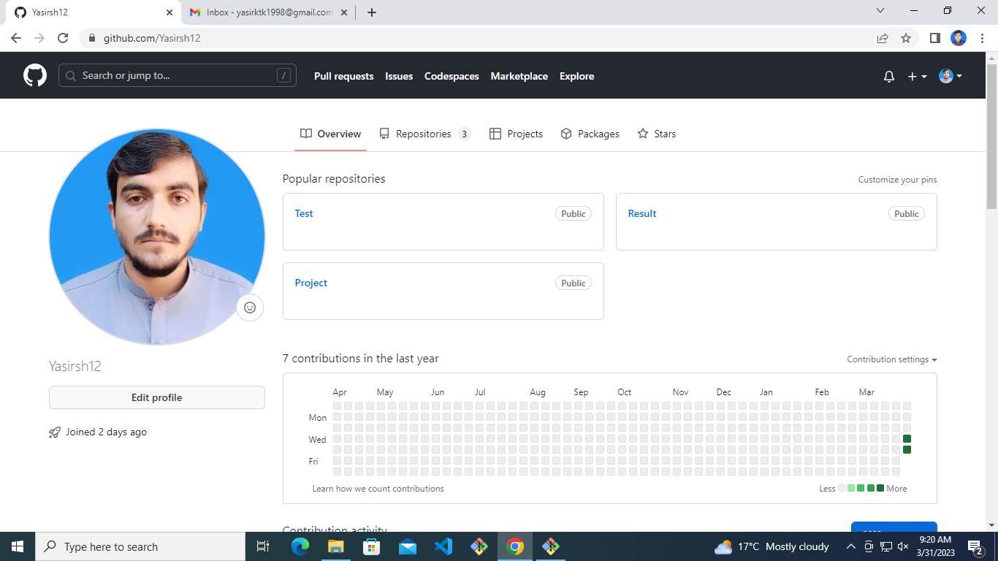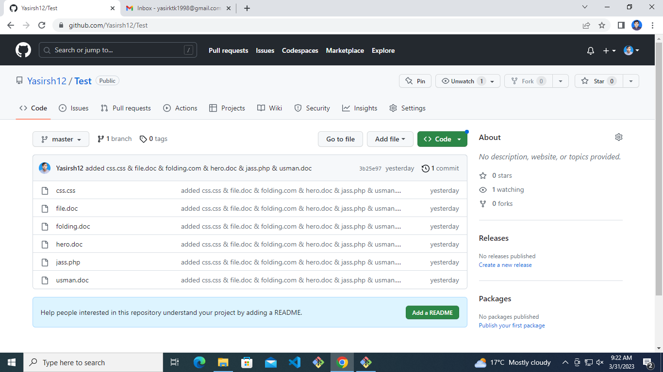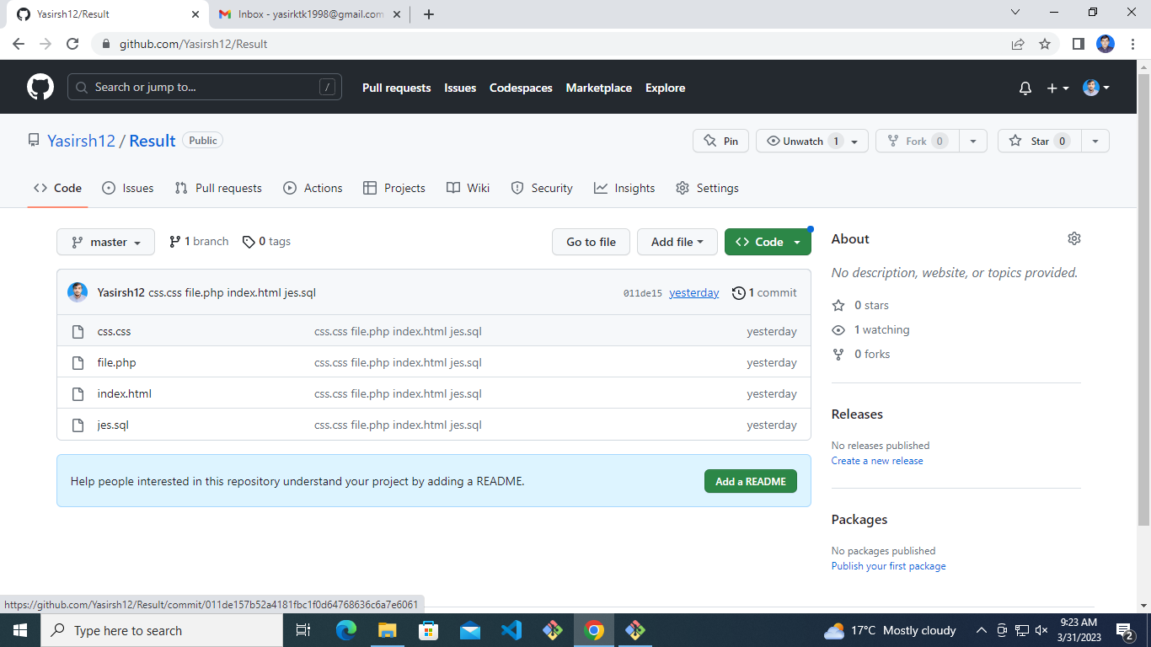

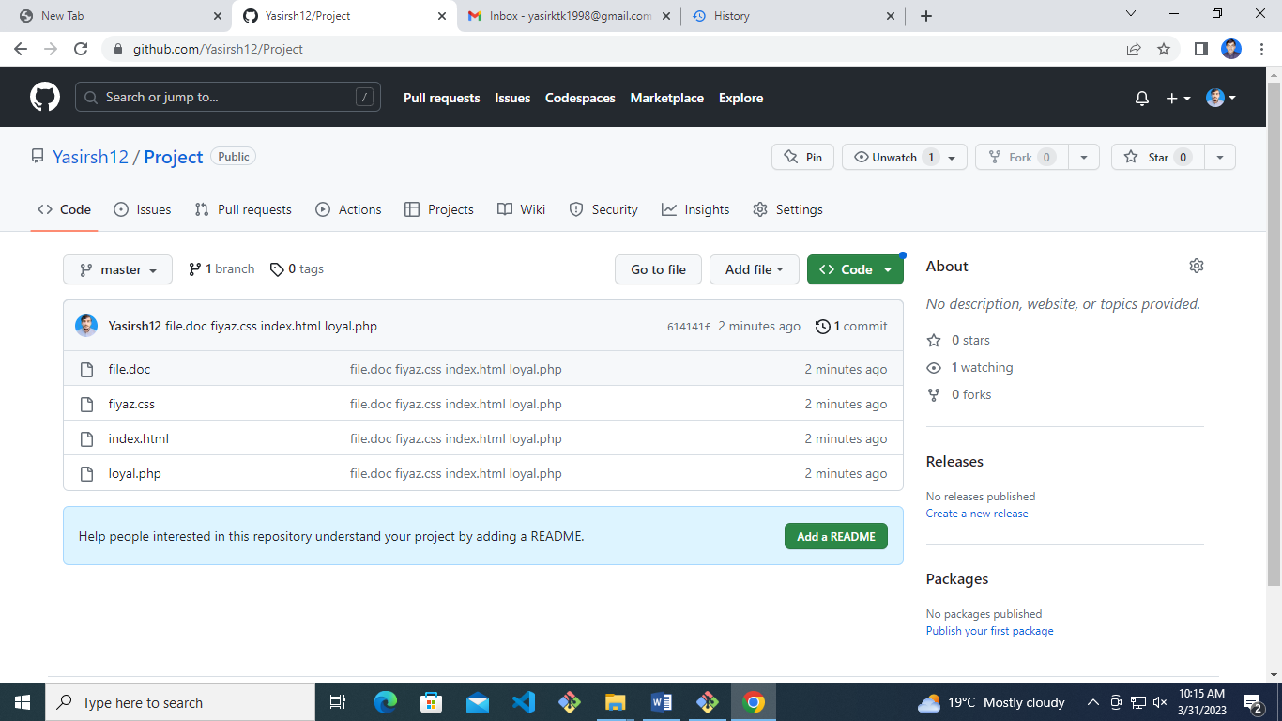

Administrator@DESKTOP-QT517IN MINGW64 ~

$ pwd

/c/Users/Administrator

Administrator@DESKTOP-QT517IN MINGW64 ~

$ ls

'3D Objects'/ Music/ Pictures/

AppData/ 'My Documents'@ PrintHood@

'Application Data'@ NTUSER.DAT Recent@

Contacts/ NTUSER.DAT{53b39e87-18c4-11ea-a811-000d3aa4692b}.TxR.0.regtrans-ms 'Saved Games'/

Cookies@ NTUSER.DAT{53b39e87-18c4-11ea-a811-000d3aa4692b}.TxR.1.regtrans-ms Searches/

Desktop/ NTUSER.DAT{53b39e87-18c4-11ea-a811-000d3aa4692b}.TxR.2.regtrans-ms SendTo@

Documents/ NTUSER.DAT{53b39e87-18c4-11ea-a811-000d3aa4692b}.TxR.blf 'Start Menu'@

Downloads/ NTUSER.DAT{53b39e88-18c4-11ea-a811-000d3aa4692b}.TM.blf Templates@

Favorites/ NTUSER.DAT{53b39e88-18c4-11ea-a811-000d3aa4692b}.TMContainer00000000000000000001.regtrans-ms Videos/

IntelGraphicsProfiles/ NTUSER.DAT{53b39e88-18c4-11ea-a811-000d3aa4692b}.TMContainer00000000000000000002.regtrans-ms ntuser.dat.LOG1

Links/ NetHood@ ntuser.dat.LOG2

'Local Settings'@ OneDrive/ ntuser.ini

Administrator@DESKTOP-QT517IN MINGW64 ~

$ cd Documents/

Administrator@DESKTOP-QT517IN MINGW64 ~/Documents

$ ls

'My Music'@ 'My Pictures'@ 'My Videos'@ VisualCode/ desktop.ini

Administrator@DESKTOP-QT517IN MINGW64 ~/Documents

$ cd VisualCode/

Administrator@DESKTOP-QT517IN MINGW64 ~/Documents/VisualCode (master)

$ ls

Class1/ project/

Administrator@DESKTOP-QT517IN MINGW64 ~/Documents/VisualCode (master)

$ cd project/

Administrator@DESKTOP-QT517IN MINGW64 ~/Documents/VisualCode/project (master)

$ ls

file.doc fiyaz.css index.html loyal.php

Administrator@DESKTOP-QT517IN MINGW64 ~/Documents/VisualCode/project (master)

$ git init

Reinitialized existing Git repository in C:/Users/Administrator/Documents/VisualCode/project/.git/

Administrator@DESKTOP-QT517IN MINGW64 ~/Documents/VisualCode/project (master)

$ git status

On branch master

No commits yet

Untracked files:

(use "git add <file>..." to include in what will be committed)

file.doc

fiyaz.css

index.html

loyal.php

nothing added to commit but untracked files present (use "git add" to track)

Administrator@DESKTOP-QT517IN MINGW64 ~/Documents/VisualCode/project (master)

$ git add -A

Administrator@DESKTOP-QT517IN MINGW64 ~/Documents/VisualCode/project (master)

$ git status

On branch master

No commits yet

Changes to be committed:

(use "git rm --cached <file>..." to unstage)

new file: file.doc

new file: fiyaz.css

new file: index.html

new file: loyal.php

Administrator@DESKTOP-QT517IN MINGW64 ~/Documents/VisualCode/project (master)

$ git commit -m 'file.doc fiyaz.css index.html loyal.php'

[master (root-commit) 614141f] file.doc fiyaz.css index.html loyal.php

4 files changed, 0 insertions(+), 0 deletions(-)

create mode 100644 file.doc

create mode 100644 fiyaz.css

create mode 100644 index.html

create mode 100644 loyal.php

Administrator@DESKTOP-QT517IN MINGW64 ~/Documents/VisualCode/project (master)

$ git status

On branch master

nothing to commit, working tree clean

Administrator@DESKTOP-QT517IN MINGW64 ~/Documents/VisualCode/project (master)

$ git remote add origin https://github.com/Yasirsh12/Project.git

Administrator@DESKTOP-QT517IN MINGW64 ~/Documents/VisualCode/project (master)

$ git push origin master

Enumerating objects: 3, done.

Counting objects: 100% (3/3), done.

Delta compression using up to 4 threads

Compressing objects: 100% (2/2), done.

Writing objects: 100% (3/3), 269 bytes | 269.00 KiB/s, done.

Total 3 (delta 0), reused 0 (delta 0), pack-reused 0

To https://github.com/Yasirsh12/Project.git

* [new branch] master -> master

Administrator@DESKTOP-QT517IN MINGW64 ~/Documents/VisualCode/project (master)

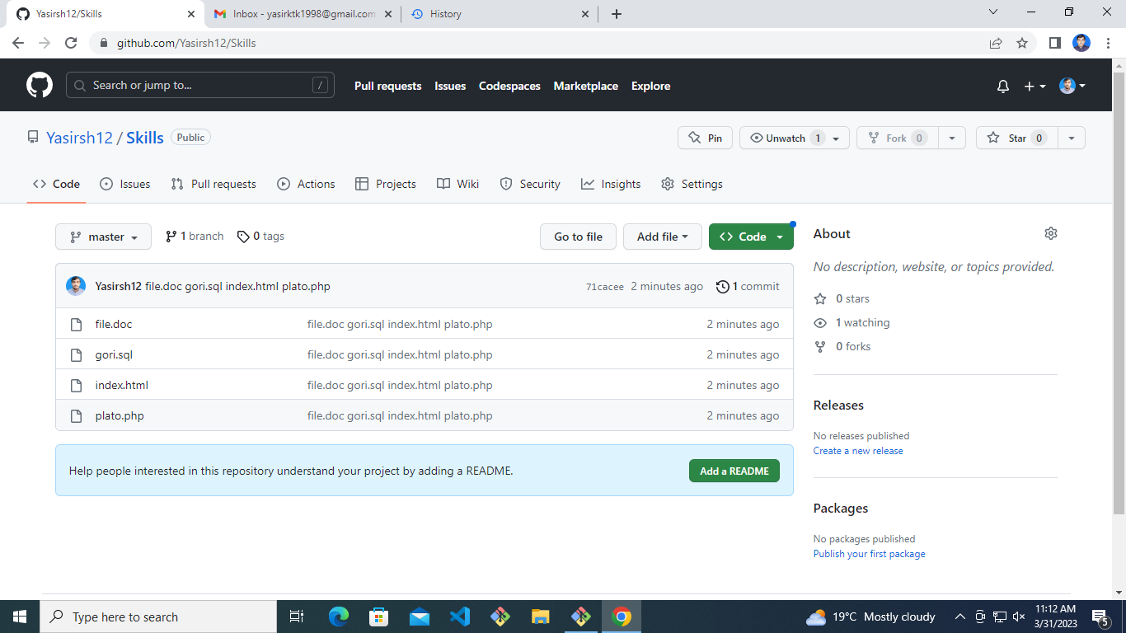$

Administrator@DESKTOP-QT517IN MINGW64 ~/Documents/VisualCode/project (master)

$ pwd

/c/Users/Administrator/Documents/VisualCode/project

Administrator@DESKTOP-QT517IN MINGW64 ~/Documents/VisualCode/project (master)

$ cd ..

Administrator@DESKTOP-QT517IN MINGW64 ~/Documents/VisualCode

$ ls

Class1/ project/

Administrator@DESKTOP-QT517IN MINGW64 ~/Documents/VisualCode

$ mkdir skills

Administrator@DESKTOP-QT517IN MINGW64 ~/Documents/VisualCode

$ ls

Class1/ project/ skills/

Administrator@DESKTOP-QT517IN MINGW64 ~/Documents/VisualCode

$ cd skills

Administrator@DESKTOP-QT517IN MINGW64 ~/Documents/VisualCode/skills

$ ls

Administrator@DESKTOP-QT517IN MINGW64 ~/Documents/VisualCode/skills

$ mkdir files images

Administrator@DESKTOP-QT517IN MINGW64 ~/Documents/VisualCode/skills

$ touch file.doc index.html plato.php gori.sql

Administrator@DESKTOP-QT517IN MINGW64 ~/Documents/VisualCode/skills

$ ls

file.doc files/ gori.sql images/ index.html plato.php

Administrator@DESKTOP-QT517IN MINGW64 ~/Documents/VisualCode/skills

$ git init

Initialized empty Git repository in C:/Users/Administrator/Documents/VisualCode/skills/.git/

Administrator@DESKTOP-QT517IN MINGW64 ~/Documents/VisualCode/skills (master)

$ git status

On branch master

No commits yet

Untracked files:

(use "git add <file>..." to include in what will be committed)

file.doc

gori.sql

index.html

plato.php

nothing added to commit but untracked files present (use "git add" to track)

Administrator@DESKTOP-QT517IN MINGW64 ~/Documents/VisualCode/skills (master)

$ git add -A

Administrator@DESKTOP-QT517IN MINGW64 ~/Documents/VisualCode/skills (master)

$ git status

On branch master

No commits yet

Changes to be committed:

(use "git rm --cached <file>..." to unstage)

new file: file.doc

new file: gori.sql

new file: index.html

new file: plato.php

Administrator@DESKTOP-QT517IN MINGW64 ~/Documents/VisualCode/skills (master)

$ git commit -m 'file.doc gori.sql index.html plato.php'

[master (root-commit) 71cacee] file.doc gori.sql index.html plato.php

4 files changed, 0 insertions(+), 0 deletions(-)

create mode 100644 file.doc

create mode 100644 gori.sql

create mode 100644 index.html

create mode 100644 plato.php

Administrator@DESKTOP-QT517IN MINGW64 ~/Documents/VisualCode/skills (master)

$ git remote add origin https://github.com/Yasirsh12/Skills.git

Administrator@DESKTOP-QT517IN MINGW64 ~/Documents/VisualCode/skills (master)

$ git push origin master

Enumerating objects: 3, done.

Counting objects: 100% (3/3), done.

Delta compression using up to 4 threads

Compressing objects: 100% (2/2), done.

Writing objects: 100% (3/3), 269 bytes | 269.00 KiB/s, done.

Total 3 (delta 0), reused 0 (delta 0), pack-reused 0

To https://github.com/Yasirsh12/Skills.git

* [new branch] master -> master

Administrator@DESKTOP-QT517IN MINGW64 ~/Documents/VisualCode/skills (master)

$

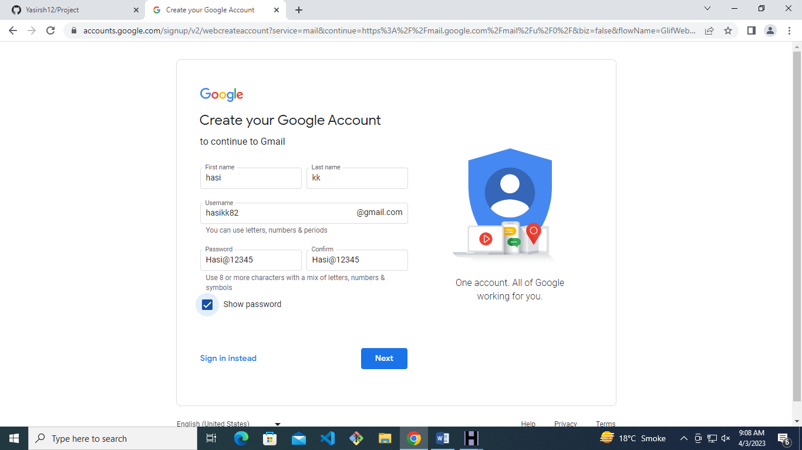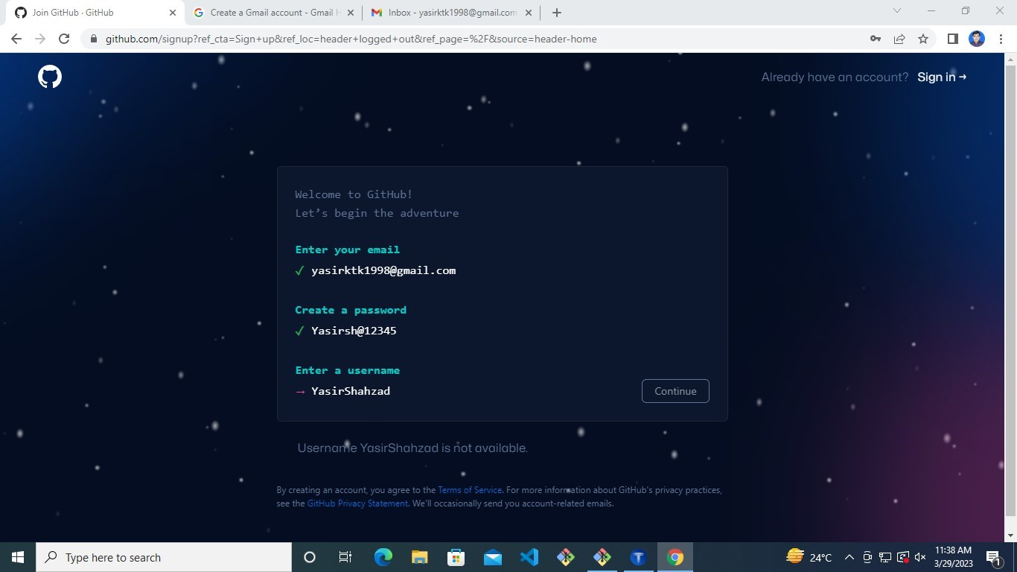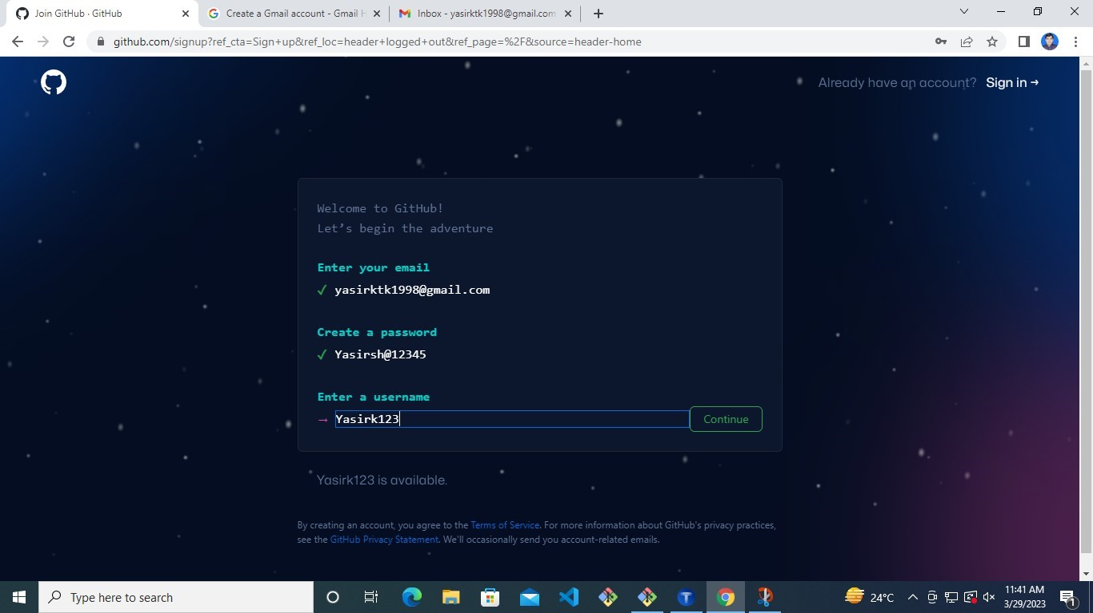

Administrator@DESKTOP-QT517IN MINGW64 ~/Documents/VisualCode

$ ls

Class1/ CloneProject/ User1/ project/ skills/ test1/

Administrator@DESKTOP-QT517IN MINGW64 ~/Documents/VisualCode

$ mkdir mussadiq

Administrator@DESKTOP-QT517IN MINGW64 ~/Documents/VisualCode

$ cd mussadiq/

Administrator@DESKTOP-QT517IN MINGW64 ~/Documents/VisualCode/mussadiq

$ touch file.doc index.html text.text

Administrator@DESKTOP-QT517IN MINGW64 ~/Documents/VisualCode/mussadiq

$ git init

Initialized empty Git repository in C:/Users/Administrator/Documents/VisualCode/mussadiq/.git/

Administrator@DESKTOP-QT517IN MINGW64 ~/Documents/VisualCode/mussadiq (master)

$ git status

On branch master

No commits yet

Untracked files:

(use "git add <file>..." to include in what will be committed)

file.doc

index.html

text.text

nothing added to commit but untracked files present (use "git add" to track)

Administrator@DESKTOP-QT517IN MINGW64 ~/Documents/VisualCode/mussadiq (master)

$ git add -A

Administrator@DESKTOP-QT517IN MINGW64 ~/Documents/VisualCode/mussadiq (master)

$ git status

On branch master

No commits yet

Changes to be committed:

(use "git rm --cached <file>..." to unstage)

new file: file.doc

new file: index.html

new file: text.text

Administrator@DESKTOP-QT517IN MINGW64 ~/Documents/VisualCode/mussadiq (master)

$ git commit -m "added file.doc index.html text.text"

[master (root-commit) 3bba8e1] added file.doc index.html text.text

3 files changed, 0 insertions(+), 0 deletions(-)

create mode 100644 file.doc

create mode 100644 index.html

create mode 100644 text.text

Administrator@DESKTOP-QT517IN MINGW64 ~/Documents/VisualCode/mussadiq (master)

$ git remote add origin https://github.com/Yasirsh12/mussadiq.git

Administrator@DESKTOP-QT517IN MINGW64 ~/Documents/VisualCode/mussadiq (master)

$ git push origin master

Enumerating objects: 3, done.

Counting objects: 100% (3/3), done.

Delta compression using up to 4 threads

Compressing objects: 100% (2/2), done.

Writing objects: 100% (3/3), 250 bytes | 250.00 KiB/s, done.

Total 3 (delta 0), reused 0 (delta 0), pack-reused 0

To https://github.com/Yasirsh12/mussadiq.git

* [new branch] master -> master

Administrator@DESKTOP-QT517IN MINGW64 ~/Documents/VisualCode/mussadiq (master)

$ git clone https://github.com/Yasirsh12/mussadiq.git

Cloning into 'mussadiq'...

remote: Enumerating objects: 3, done.

remote: Counting objects: 100% (3/3), done.

remote: Compressing objects: 100% (2/2), done.

remote: Total 3 (delta 0), reused 3 (delta 0), pack-reused 0

Receiving objects: 100% (3/3), done.

Administrator@DESKTOP-QT517IN MINGW64 ~/Documents/VisualCode/mussadiq (master)

$ ls

file.doc index.html mussadiq/ text.text

Administrator@DESKTOP-QT517IN MINGW64 ~/Documents/VisualCode/mussadiq (master)

$ touch gogli.sql

Administrator@DESKTOP-QT517IN MINGW64 ~/Documents/VisualCode/mussadiq (master)

$ git add -A

warning: adding embedded git repository: mussadiq

hint: You've added another git repository inside your current repository.

hint: Clones of the outer repository will not contain the contents of

hint: the embedded repository and will not know how to obtain it.

hint: If you meant to add a submodule, use:

hint:

hint: git submodule add <url> mussadiq

hint:

hint: If you added this path by mistake, you can remove it from the

hint: index with:

hint:

hint: git rm --cached mussadiq

hint:

hint: See "git help submodule" for more information.

g

Administrator@DESKTOP-QT517IN MINGW64 ~/Documents/VisualCode/mussadiq (master)

$ git commit -m "done"

[master 7e372df] done

2 files changed, 1 insertion(+)

create mode 100644 gogli.sql

create mode 160000 mussadiq

Administrator@DESKTOP-QT517IN MINGW64 ~/Documents/VisualCode/mussadiq (master)

$ git push master origin

error: src refspec origin does not match any

error: failed to push some refs to 'master'

Administrator@DESKTOP-QT517IN MINGW64 ~/Documents/VisualCode/mussadiq (master)

$ git push origin master

Enumerating objects: 3, done.

Counting objects: 100% (3/3), done.

Delta compression using up to 4 threads

Compressing objects: 100% (2/2), done.

Writing objects: 100% (2/2), 300 bytes | 300.00 KiB/s, done.

Total 2 (delta 0), reused 0 (delta 0), pack-reused 0

To https://github.com/Yasirsh12/mussadiq.git

3bba8e1..7e372df master -> master

c

Administrator@DESKTOP-QT517IN MINGW64 ~/Documents/VisualCode/mussadiq (master)

$ cd mussadiq/

Administrator@DESKTOP-QT517IN MINGW64 ~/Documents/VisualCode/mussadiq/mussadiq (master)

$ git push origin master

To https://github.com/Yasirsh12/mussadiq.git

! [rejected] master -> master (fetch first)

error: failed to push some refs to 'https://github.com/Yasirsh12/mussadiq.git'

hint: Updates were rejected because the remote contains work that you do

hint: not have locally. This is usually caused by another repository pushing

hint: to the same ref. You may want to first integrate the remote changes

hint: (e.g., 'git pull ...') before pushing again.

hint: See the 'Note about fast-forwards' in 'git push --help' for details.

Administrator@DESKTOP-QT517IN MINGW64 ~/Documents/VisualCode/mussadiq/mussadiq (master)

$ git branch

* master

Administrator@DESKTOP-QT517IN MINGW64 ~/Documents/VisualCode/mussadiq/mussadiq (master)

$ git branch obaid

Administrator@DESKTOP-QT517IN MINGW64 ~/Documents/VisualCode/mussadiq/mussadiq (master)

$ git branch

* master

obaid

Administrator@DESKTOP-QT517IN MINGW64 ~/Documents/VisualCode/mussadiq/mussadiq (master)

$ git checkout obaid

Switched to branch 'obaid'

Administrator@DESKTOP-QT517IN MINGW64 ~/Documents/VisualCode/mussadiq/mussadiq (obaid)

$ git branch

master

* obaid

Administrator@DESKTOP-QT517IN MINGW64 ~/Documents/VisualCode/mussadiq/mussadiq (obaid)

$ git push origin obaid

Enumerating objects: 3, done.

Counting objects: 100% (3/3), done.

Delta compression using up to 4 threads

Compressing objects: 100% (2/2), done.

Writing objects: 100% (3/3), 250 bytes | 250.00 KiB/s, done.

Total 3 (delta 0), reused 3 (delta 0), pack-reused 0

remote:

remote: Create a pull request for 'obaid' on GitHub by visiting:

remote: https://github.com/Yasirsh12/mussadiq/pull/new/obaid

remote:

To https://github.com/Yasirsh12/mussadiq.git

* [new branch] obaid -> obaid

Administrator@DESKTOP-QT517IN MINGW64 ~/Documents/VisualCode/mussadiq/mussadiq (obaid)

$ git checkout master

Switched to branch 'master'

Your branch is up to date with 'origin/master'.

Administrator@DESKTOP-QT517IN MINGW64 ~/Documents/VisualCode/mussadiq/mussadiq (master)

$ git branch

* master

obaid

Administrator@DESKTOP-QT517IN MINGW64 ~/Documents/VisualCode/mussadiq/mussadiq (master)

$ git status

On branch master

Your branch is up to date with 'origin/master'.

nothing to commit, working tree clean

Administrator@DESKTOP-QT517IN MINGW64 ~/Documents/VisualCode/mussadiq/mussadiq (master)

$ ls

file.doc index.html text.text

Administrator@DESKTOP-QT517IN MINGW64 ~/Documents/VisualCode/mussadiq/mussadiq (master)

$ git pull origin master

remote: Enumerating objects: 3, done.

remote: Counting objects: 100% (3/3), done.

remote: Compressing objects: 100% (2/2), done.

remote: Total 2 (delta 0), reused 2 (delta 0), pack-reused 0

Unpacking objects: 100% (2/2), 280 bytes | 56.00 KiB/s, done.

From https://github.com/Yasirsh12/mussadiq

* branch master -> FETCH_HEAD

3bba8e1..7e372df master -> origin/master

Updating 3bba8e1..7e372df

Fast-forward

gogli.sql | 0

mussadiq | 1 +

2 files changed, 1 insertion(+)

create mode 100644 gogli.sql

create mode 160000 mussadiq

Administrator@DESKTOP-QT517IN MINGW64 ~/Documents/VisualCode/mussadiq/mussadiq (master)

$ git config --global --list

gui.recentrepo=C:/Users/Administrator/Documents/VisualCode/Class1

user.email=yasirktk1998@gmail.com

user.name=Yasirsh12

Administrator@DESKTOP-QT517IN MINGW64 ~/Documents/VisualCode/mussadiq/mussadiq (master)

$ git log

commit 7e372df82747daf43e9a54a413110eaeb044f8ca (HEAD -> master, origin/master, origin/HEAD)

Author: Yasirsh12 <yasirktk1998@gmail.com>

Date: Tue Apr 4 14:34:51 2023 -0700

done

commit 3bba8e157e352f196a4fa9d93292d3a6b5615983 (origin/obaid, obaid)

Author: Yasirsh12 <yasirktk1998@gmail.com>

Date: Tue Apr 4 14:19:06 2023 -0700

added file.doc index.html text.text

Administrator@DESKTOP-QT517IN MINGW64 ~/Documents/VisualCode/mussadiq/mussadiq (master)

$ git log -2

commit 7e372df82747daf43e9a54a413110eaeb044f8ca (HEAD -> master, origin/master, origin/HEAD)

Author: Yasirsh12 <yasirktk1998@gmail.com>

Date: Tue Apr 4 14:34:51 2023 -0700

done

commit 3bba8e157e352f196a4fa9d93292d3a6b5615983 (origin/obaid, obaid)

Author: Yasirsh12 <yasirktk1998@gmail.com>

Date: Tue Apr 4 14:19:06 2023 -0700

added file.doc index.html text.text

Administrator@DESKTOP-QT517IN MINGW64 ~/Documents/VisualCode/mussadiq/mussadiq (master)

$ git log oneline

fatal: ambiguous argument 'oneline': unknown revision or path not in the working tree.

Use '--' to separate paths from revisions, like this:

'git <command> [<revision>...] -- [<file>...]'

Administrator@DESKTOP-QT517IN MINGW64 ~/Documents/VisualCode/mussadiq/mussadiq (master)

$ git log --oneline

7e372df (HEAD -> master, origin/master, origin/HEAD) done

3bba8e1 (origin/obaid, obaid) added file.doc index.html text.text

Administrator@DESKTOP-QT517IN MINGW64 ~/Documents/VisualCode/mussadiq/mussadiq (master)

$ git log --grep = "index.html"

Administrator@DESKTOP-QT517IN MINGW64 ~/Documents/VisualCode/mussadiq/mussadiq (master)

$ git status

On branch master

Your branch is up to date with 'origin/master'.

nothing to commit, working tree clean

Administrator@DESKTOP-QT517IN MINGW64 ~/Documents/VisualCode/mussadiq/mussadiq (master)

$

**Cherry cmd**

Administrator@DESKTOP-QT517IN MINGW64 ~

$ ls

'3D Objects'/ Music/ Pictures/

AppData/ 'My Documents'@ PrintHood@

'Application Data'@ NTUSER.DAT Recent@

Contacts/ NTUSER.DAT{53b39e87-18c4-11ea-a811-000d3aa4692b}.TxR.0.regtrans-ms 'Saved Games'/

Cookies@ NTUSER.DAT{53b39e87-18c4-11ea-a811-000d3aa4692b}.TxR.1.regtrans-ms Searches/

Desktop/ NTUSER.DAT{53b39e87-18c4-11ea-a811-000d3aa4692b}.TxR.2.regtrans-ms SendTo@

Documents/ NTUSER.DAT{53b39e87-18c4-11ea-a811-000d3aa4692b}.TxR.blf 'Start Menu'@

Downloads/ NTUSER.DAT{53b39e88-18c4-11ea-a811-000d3aa4692b}.TM.blf Templates@

Favorites/ NTUSER.DAT{53b39e88-18c4-11ea-a811-000d3aa4692b}.TMContainer00000000000000000001.regtrans-ms Videos/

IntelGraphicsProfiles/ NTUSER.DAT{53b39e88-18c4-11ea-a811-000d3aa4692b}.TMContainer00000000000000000002.regtrans-ms ntuser.dat.LOG1

Links/ NetHood@ ntuser.dat.LOG2

'Local Settings'@ OneDrive/ ntuser.ini

Administrator@DESKTOP-QT517IN MINGW64 ~

$ cd Documents/VisualCode/

Administrator@DESKTOP-QT517IN MINGW64 ~/Documents/VisualCode

$ ls

Class1/ CloneProject/ User1/ mussadiq/ project/ skills/ test1/ user2/ user3/

Administrator@DESKTOP-QT517IN MINGW64 ~/Documents/VisualCode

$ cd CloneProject/

Administrator@DESKTOP-QT517IN MINGW64 ~/Documents/VisualCode/CloneProject (master)

$ ls

file.doc file.php hy.txt index.txt stash.html

Administrator@DESKTOP-QT517IN MINGW64 ~/Documents/VisualCode/CloneProject (master)

$ git branch yasir

Administrator@DESKTOP-QT517IN MINGW64 ~/Documents/VisualCode/CloneProject (master)

$ git branch

* master

test

yasir

Administrator@DESKTOP-QT517IN MINGW64 ~/Documents/VisualCode/CloneProject (master)

$ git checkout yasir

Switched to branch 'yasir'

Administrator@DESKTOP-QT517IN MINGW64 ~/Documents/VisualCode/CloneProject (yasir)

$ git branch

master

test

* yasir

Administrator@DESKTOP-QT517IN MINGW64 ~/Documents/VisualCode/CloneProject (yasir)

$ touch hy.doc

Administrator@DESKTOP-QT517IN MINGW64 ~/Documents/VisualCode/CloneProject (yasir)

$ git add hy.doc

Administrator@DESKTOP-QT517IN MINGW64 ~/Documents/VisualCode/CloneProject (yasir)

$ git commit -m "hy.doc"

[yasir 048cc4e] hy.doc

1 file changed, 0 insertions(+), 0 deletions(-)

create mode 100644 hy.doc

Administrator@DESKTOP-QT517IN MINGW64 ~/Documents/VisualCode/CloneProject (yasir)

$ git log

commit 048cc4eca2ed27612952a0e7a20fab44b39b7fe2 (HEAD -> yasir)

Author: Yasirsh12 <yasirktk1998@gmail.com>

Date: Fri Apr 7 09:07:36 2023 -0700

hy.doc

commit 3afbc9e2f1c94f17bbc4412ed0f8b6628e79e03b (master)

Author: Yasirsh12 <yasirktk1998@gmail.com>

Date: Thu Apr 6 12:00:45 2023 -0700

hy.txt

commit c5aa0692ab46a24d943161a2dc54f022105b8945 (origin/master)

Author: Yasirsh12 <yasirktk1998@gmail.com>

Date: Tue Apr 4 12:06:37 2023 -0700

done

commit fdaeb8f801140b775c31b91681833c631259687a

Author: Yasirsh12 <yasirktk1998@gmail.com>

Date: Tue Apr 4 12:02:05 2023 -0700

added file.doc index.txt

Administrator@DESKTOP-QT517IN MINGW64 ~/Documents/VisualCode/CloneProject (yasir)

$ ^C

Administrator@DESKTOP-QT517IN MINGW64 ~/Documents/VisualCode/CloneProject (yasir)

$ git checkout master

Switched to branch 'master'

Administrator@DESKTOP-QT517IN MINGW64 ~/Documents/VisualCode/CloneProject (master)

$ git cherry-pick 048cc4eca2ed27612952a0e7a20fab44b39b7fe2

[master 00233d1] hy.doc

Date: Fri Apr 7 09:07:36 2023 -0700

1 file changed, 0 insertions(+), 0 deletions(-)

create mode 100644 hy.doc

Administrator@DESKTOP-QT517IN MINGW64 ~/Documents/VisualCode/CloneProject (master)

$ lis

bash: lis: command not found

Administrator@DESKTOP-QT517IN MINGW64 ~/Documents/VisualCode/CloneProject (master)

$ ls

file.doc file.php hy.doc hy.txt index.txt stash.html

Administrator@DESKTOP-QT517IN MINGW64 ~/Documents/VisualCode/CloneProject (master)

$

Administrator@DESKTOP-QT517IN MINGW64 ~

$ cd Documents/VisualCode/

Administrator@DESKTOP-QT517IN MINGW64 ~/Documents/VisualCode

$ ls

Class1/ CloneProject/ User1/ mussadiq/ project/ skills/ ssh/ test1/

Administrator@DESKTOP-QT517IN MINGW64 ~/Documents/VisualCode

$ mkdir admin user1 user2

mkdir: cannot create directory ‘user1’: File exists

Administrator@DESKTOP-QT517IN MINGW64 ~/Documents/VisualCode

$ cd User1/

Administrator@DESKTOP-QT517IN MINGW64 ~/Documents/VisualCode/User1 (master)

$ ls

Test/ file.doc file.php index.txt

Administrator@DESKTOP-QT517IN MINGW64 ~/Documents/VisualCode/User1 (master)

$ cd ..

Administrator@DESKTOP-QT517IN MINGW64 ~/Documents/VisualCode

$ ls

Class1/ User1/ mussadiq/ skills/ test1/

CloneProject/ admin/ project/ ssh/ user2/

Administrator@DESKTOP-QT517IN MINGW64 ~/Documents/VisualCode

$ rm -rf user2 admin

Administrator@DESKTOP-QT517IN MINGW64 ~/Documents/VisualCode

$ ls

Class1/ CloneProject/ User1/ mussadiq/ project/ skills/ ssh/ test1/

Administrator@DESKTOP-QT517IN MINGW64 ~/Documents/VisualCode

$ mkdir

mkdir: missing operand

Try 'mkdir --help' for more information.

Administrator@DESKTOP-QT517IN MINGW64 ~/Documents/VisualCode

$ mkdir Conflect

Administrator@DESKTOP-QT517IN MINGW64 ~/Documents/VisualCode

$ cd Conflect/

Administrator@DESKTOP-QT517IN MINGW64 ~/Documents/VisualCode/Conflect

$ mkdir admin user1 user2

Administrator@DESKTOP-QT517IN MINGW64 ~/Documents/VisualCode/Conflect

$ cd admin

Administrator@DESKTOP-QT517IN MINGW64 ~/Documents/VisualCode/Conflect/admin

$ git init

Initialized empty Git repository in C:/Users/Administrator/Documents/VisualCode/Conflect/admin/.git/

Administrator@DESKTOP-QT517IN MINGW64 ~/Documents/VisualCode/Conflect/admin (master)

$ touch index.html

Administrator@DESKTOP-QT517IN MINGW64 ~/Documents/VisualCode/Conflect/admin (master)

$ git add .

Administrator@DESKTOP-QT517IN MINGW64 ~/Documents/VisualCode/Conflect/admin (master)

$ gut commit -m "added by admin index.html"

bash: gut: command not found

Administrator@DESKTOP-QT517IN MINGW64 ~/Documents/VisualCode/Conflect/admin (master)

$ git commit -m "added by admin index.html"

[master (root-commit) 95d5cfa] added by admin index.html

1 file changed, 0 insertions(+), 0 deletions(-)

create mode 100644 index.html

Administrator@DESKTOP-QT517IN MINGW64 ~/Documents/VisualCode/Conflect/admin (master)

$ git remote add origin https://github.com/Yasirsh12/conflect.git

Administrator@DESKTOP-QT517IN MINGW64 ~/Documents/VisualCode/Conflect/admin (master)

$ git push origin master

Enumerating objects: 3, done.

Counting objects: 100% (3/3), done.

Writing objects: 100% (3/3), 225 bytes | 225.00 KiB/s, done.

Total 3 (delta 0), reused 0 (delta 0), pack-reused 0

To https://github.com/Yasirsh12/conflect.git

* [new branch] master -> master

Administrator@DESKTOP-QT517IN MINGW64 ~/Documents/VisualCode/Conflect/admin (master)

$ cd ..

Administrator@DESKTOP-QT517IN MINGW64 ~/Documents/VisualCode/Conflect

$ cd user1/

Administrator@DESKTOP-QT517IN MINGW64 ~/Documents/VisualCode/Conflect/user1

$ git clone https://github.com/Yasirsh12/conflect.git

Cloning into 'conflect'...

remote: Enumerating objects: 3, done.

remote: Counting objects: 100% (3/3), done.

remote: Total 3 (delta 0), reused 3 (delta 0), pack-reused 0

Receiving objects: 100% (3/3), done.

Administrator@DESKTOP-QT517IN MINGW64 ~/Documents/VisualCode/Conflect/user1

$ cd ..

Administrator@DESKTOP-QT517IN MINGW64 ~/Documents/VisualCode/Conflect

$ cd user2/

Administrator@DESKTOP-QT517IN MINGW64 ~/Documents/VisualCode/Conflect/user2

$ git clone https://github.com/Yasirsh12/conflect.git

Cloning into 'conflect'...

remote: Enumerating objects: 3, done.

remote: Counting objects: 100% (3/3), done.

remote: Total 3 (delta 0), reused 3 (delta 0), pack-reused 0

Receiving objects: 100% (3/3), done.

Administrator@DESKTOP-QT517IN MINGW64 ~/Documents/VisualCode/Conflect/user2

$ cd ..

Administrator@DESKTOP-QT517IN MINGW64 ~/Documents/VisualCode/Conflect

$ cd user1/

Administrator@DESKTOP-QT517IN MINGW64 ~/Documents/VisualCode/Conflect/user1

$ ls

conflect/

Administrator@DESKTOP-QT517IN MINGW64 ~/Documents/VisualCode/Conflect/user1

$ cd conflect/

Administrator@DESKTOP-QT517IN MINGW64 ~/Documents/VisualCode/Conflect/user1/conflect (master)

$ ls

index.html

Administrator@DESKTOP-QT517IN MINGW64 ~/Documents/VisualCode/Conflect/user1/conflect (master)

$ code index.html

Administrator@DESKTOP-QT517IN MINGW64 ~/Documents/VisualCode/Conflect/user1/conflect (master)

$ git status

On branch master

Your branch is up to date with 'origin/master'.

Changes not staged for commit:

(use "git add <file>..." to update what will be committed)

(use "git restore <file>..." to discard changes in working directory)

modified: index.html

no changes added to commit (use "git add" and/or "git commit -a")

Administrator@DESKTOP-QT517IN MINGW64 ~/Documents/VisualCode/Conflect/user1/conflect (master)

$ git add .

Administrator@DESKTOP-QT517IN MINGW64 ~/Documents/VisualCode/Conflect/user1/conflect (master)

$ git commit -m "added by user1 index.html"

[master f64635f] added by user1 index.html

1 file changed, 12 insertions(+)

Administrator@DESKTOP-QT517IN MINGW64 ~/Documents/VisualCode/Conflect/user1/conflect (master)

$ git push origin master

Enumerating objects: 5, done.

Counting objects: 100% (5/5), done.

Delta compression using up to 4 threads

Compressing objects: 100% (2/2), done.

Writing objects: 100% (3/3), 452 bytes | 452.00 KiB/s, done.

Total 3 (delta 0), reused 0 (delta 0), pack-reused 0

To https://github.com/Yasirsh12/conflect.git

95d5cfa..f64635f master -> master

Administrator@DESKTOP-QT517IN MINGW64 ~/Documents/VisualCode/Conflect/user1/conflect (master)

$ cd ..

Administrator@DESKTOP-QT517IN MINGW64 ~/Documents/VisualCode/Conflect/user1

$ cd ..

Administrator@DESKTOP-QT517IN MINGW64 ~/Documents/VisualCode/Conflect

$ cd user2/

Administrator@DESKTOP-QT517IN MINGW64 ~/Documents/VisualCode/Conflect/user2

$ cd conflect/

Administrator@DESKTOP-QT517IN MINGW64 ~/Documents/VisualCode/Conflect/user2/conflect (master)

$ ls

index.html

Administrator@DESKTOP-QT517IN MINGW64 ~/Documents/VisualCode/Conflect/user2/conflect (master)

$ code index.html

Administrator@DESKTOP-QT517IN MINGW64 ~/Documents/VisualCode/Conflect/user2/conflect (master)

$ git add .

Administrator@DESKTOP-QT517IN MINGW64 ~/Documents/VisualCode/Conflect/user2/conflect (master)

$ git commit -m "added user2 index.html"

[master 728eaae] added user2 index.html

1 file changed, 12 insertions(+)

Administrator@DESKTOP-QT517IN MINGW64 ~/Documents/VisualCode/Conflect/user2/conflect (master)

$ git push origin master

To https://github.com/Yasirsh12/conflect.git

! [rejected] master -> master (fetch first)

error: failed to push some refs to 'https://github.com/Yasirsh12/conflect.git'

hint: Updates were rejected because the remote contains work that you do

hint: not have locally. This is usually caused by another repository pushing

hint: to the same ref. You may want to first integrate the remote changes

hint: (e.g., 'git pull ...') before pushing again.

hint: See the 'Note about fast-forwards' in 'git push --help' for details.

Administrator@DESKTOP-QT517IN MINGW64 ~/Documents/VisualCode/Conflect/user2/conflect (master)

$ cd ..

Administrator@DESKTOP-QT517IN MINGW64 ~/Documents/VisualCode/Conflect/user2

$ cd ..

Administrator@DESKTOP-QT517IN MINGW64 ~/Documents/VisualCode/Conflect

$ ls

admin/ user1/ user2/

Administrator@DESKTOP-QT517IN MINGW64 ~/Documents/VisualCode/Conflect

$ cd user1/

Administrator@DESKTOP-QT517IN MINGW64 ~/Documents/VisualCode/Conflect/user1

$ cd conflect/

Administrator@DESKTOP-QT517IN MINGW64 ~/Documents/VisualCode/Conflect/user1/conflect (master)

$ ls

index.html

Administrator@DESKTOP-QT517IN MINGW64 ~/Documents/VisualCode/Conflect/user1/conflect (master)

$ git checkout -b code1

Switched to a new branch 'code1'

Administrator@DESKTOP-QT517IN MINGW64 ~/Documents/VisualCode/Conflect/user1/conflect (code1)

$ ls

index.html

Administrator@DESKTOP-QT517IN MINGW64 ~/Documents/VisualCode/Conflect/user1/conflect (code1)

$ code index.html

Administrator@DESKTOP-QT517IN MINGW64 ~/Documents/VisualCode/Conflect/user1/conflect (code1)

$ git status

On branch code1

Changes not staged for commit:

(use "git add <file>..." to update what will be committed)

(use "git restore <file>..." to discard changes in working directory)

modified: index.html

no changes added to commit (use "git add" and/or "git commit -a")

Administrator@DESKTOP-QT517IN MINGW64 ~/Documents/VisualCode/Conflect/user1/conflect (code1)

$ git add .

Administrator@DESKTOP-QT517IN MINGW64 ~/Documents/VisualCode/Conflect/user1/conflect (code1)

$ git commit -m "added by user1 branch code1 index.html"

[code1 ae2ad07] added by user1 branch code1 index.html

1 file changed, 1 insertion(+), 1 deletion(-)

Administrator@DESKTOP-QT517IN MINGW64 ~/Documents/VisualCode/Conflect/user1/conflect (code1)

$ git push origin code1

Enumerating objects: 5, done.

Counting objects: 100% (5/5), done.

Delta compression using up to 4 threads

Compressing objects: 100% (2/2), done.

Writing objects: 100% (3/3), 327 bytes | 327.00 KiB/s, done.

Total 3 (delta 1), reused 0 (delta 0), pack-reused 0

remote: Resolving deltas: 100% (1/1), completed with 1 local object.

remote:

remote: Create a pull request for 'code1' on GitHub by visiting:

remote: https://github.com/Yasirsh12/conflect/pull/new/code1

remote:

To https://github.com/Yasirsh12/conflect.git

* [new branch] code1 -> code1

Administrator@DESKTOP-QT517IN MINGW64 ~/Documents/VisualCode/Conflect/user1/conflect (code1)

$ cd ..

Administrator@DESKTOP-QT517IN MINGW64 ~/Documents/VisualCode/Conflect/user1

$ cd ..

Administrator@DESKTOP-QT517IN MINGW64 ~/Documents/VisualCode/Conflect

$ cd user2/

Administrator@DESKTOP-QT517IN MINGW64 ~/Documents/VisualCode/Conflect/user2

$ ls

conflect/

Administrator@DESKTOP-QT517IN MINGW64 ~/Documents/VisualCode/Conflect/user2

$ cd conflect/

Administrator@DESKTOP-QT517IN MINGW64 ~/Documents/VisualCode/Conflect/user2/conflect (master)

$ git checkout -b code2

Switched to a new branch 'code2'

Administrator@DESKTOP-QT517IN MINGW64 ~/Documents/VisualCode/Conflect/user2/conflect (code2)

$ code index.html

Administrator@DESKTOP-QT517IN MINGW64 ~/Documents/VisualCode/Conflect/user2/conflect (code2)

$ git add .

Administrator@DESKTOP-QT517IN MINGW64 ~/Documents/VisualCode/Conflect/user2/conflect (code2)

$ git commit -m "added by user2 and branch code2"

[code2 b064ffb] added by user2 and branch code2

1 file changed, 1 insertion(+), 1 deletion(-)

Administrator@DESKTOP-QT517IN MINGW64 ~/Documents/VisualCode/Conflect/user2/conflect (code2)

$ git push origin code2

Enumerating objects: 9, done.

Counting objects: 100% (9/9), done.

Delta compression using up to 4 threads

Compressing objects: 100% (5/5), done.

Writing objects: 100% (9/9), 914 bytes | 914.00 KiB/s, done.

Total 9 (delta 1), reused 3 (delta 0), pack-reused 0

remote: Resolving deltas: 100% (1/1), done.

remote:

remote: Create a pull request for 'code2' on GitHub by visiting:

remote: https://github.com/Yasirsh12/conflect/pull/new/code2

remote:

To https://github.com/Yasirsh12/conflect.git

* [new branch] code2 -> code2

Administrator@DESKTOP-QT517IN MINGW64 ~/Documents/VisualCode/Conflect/user2/conflect (code2)

$ cd ..

Administrator@DESKTOP-QT517IN MINGW64 ~/Documents/VisualCode/Conflect/user2

$ cd ..

Administrator@DESKTOP-QT517IN MINGW64 ~/Documents/VisualCode/Conflect

$ ls

admin/ user1/ user2/

Administrator@DESKTOP-QT517IN MINGW64 ~/Documents/VisualCode/Conflect

$ code admin/

Administrator@DESKTOP-QT517IN MINGW64 ~/Documents/VisualCode/Conflect

$ cd admin/

Administrator@DESKTOP-QT517IN MINGW64 ~/Documents/VisualCode/Conflect/admin (master)

$ ls

index.html

Administrator@DESKTOP-QT517IN MINGW64 ~/Documents/VisualCode/Conflect/admin (master)

$ git status

On branch master

nothing to commit, working tree clean

Administrator@DESKTOP-QT517IN MINGW64 ~/Documents/VisualCode/Conflect/admin (master)

$ git push origin master

To https://github.com/Yasirsh12/conflect.git

! [rejected] master -> master (fetch first)

error: failed to push some refs to 'https://github.com/Yasirsh12/conflect.git'

hint: Updates were rejected because the remote contains work that you do

hint: not have locally. This is usually caused by another repository pushing

hint: to the same ref. You may want to first integrate the remote changes

hint: (e.g., 'git pull ...') before pushing again.

hint: See the 'Note about fast-forwards' in 'git push --help' for details.

Administrator@DESKTOP-QT517IN MINGW64 ~/Documents/VisualCode/Conflect/admin (master)

$ cd ..

Administrator@DESKTOP-QT517IN MINGW64 ~/Documents/VisualCode/Conflect

$ cd user1/

Administrator@DESKTOP-QT517IN MINGW64 ~/Documents/VisualCode/Conflect/user1

$ ls

conflect/

Administrator@DESKTOP-QT517IN MINGW64 ~/Documents/VisualCode/Conflect/user1

$ cd conflect/

Administrator@DESKTOP-QT517IN MINGW64 ~/Documents/VisualCode/Conflect/user1/conflect (code1)

$ code index.html

Administrator@DESKTOP-QT517IN MINGW64 ~/Documents/VisualCode/Conflect/user1/conflect (code1)

$ cd ..

Administrator@DESKTOP-QT517IN MINGW64 ~/Documents/VisualCode/Conflect/user1

$ cd ..

Administrator@DESKTOP-QT517IN MINGW64 ~/Documents/VisualCode/Conflect

$ cd admin/

Administrator@DESKTOP-QT517IN MINGW64 ~/Documents/VisualCode/Conflect/admin (master)

$ ls

index.html

Administrator@DESKTOP-QT517IN MINGW64 ~/Documents/VisualCode/Conflect/admin (master)

$ code index.html

Administrator@DESKTOP-QT517IN MINGW64 ~/Documents/VisualCode/Conflect/admin (master)

$ git pull origin code1

remote: Enumerating objects: 8, done.

remote: Counting objects: 100% (8/8), done.

remote: Compressing objects: 100% (3/3), done.

remote: Total 6 (delta 1), reused 6 (delta 1), pack-reused 0

Unpacking objects: 100% (6/6), 709 bytes | 41.00 KiB/s, done.

From https://github.com/Yasirsh12/conflect

* branch code1 -> FETCH_HEAD

* [new branch] code1 -> origin/code1

Updating 95d5cfa..ae2ad07

Fast-forward

index.html | 12 ++++++++++++

1 file changed, 12 insertions(+)

Administrator@DESKTOP-QT517IN MINGW64 ~/Documents/VisualCode/Conflect/admin (master)

$ git status

On branch master

nothing to commit, working tree clean

Administrator@DESKTOP-QT517IN MINGW64 ~/Documents/VisualCode/Conflect/admin (master)

$ code index.html

Administrator@DESKTOP-QT517IN MINGW64 ~/Documents/VisualCode/Conflect/admin (master)

$ git pull origin code2

remote: Enumerating objects: 8, done.

remote: Counting objects: 100% (8/8), done.

remote: Compressing objects: 100% (3/3), done.

remote: Total 6 (delta 1), reused 6 (delta 1), pack-reused 0

Unpacking objects: 100% (6/6), 701 bytes | 38.00 KiB/s, done.

From https://github.com/Yasirsh12/conflect

* branch code2 -> FETCH_HEAD

* [new branch] code2 -> origin/code2

Auto-merging index.html

CONFLICT (content): Merge conflict in index.html

Automatic merge failed; fix conflicts and then commit the result.

Administrator@DESKTOP-QT517IN MINGW64 ~/Documents/VisualCode/Conflect/admin (master|MERGING)

$ code index.html

Administrator@DESKTOP-QT517IN MINGW64 ~/Documents/VisualCode/Conflect/admin (master|MERGING)

$ git status

On branch master

You have unmerged paths.

(fix conflicts and run "git commit")

(use "git merge --abort" to abort the merge)

Unmerged paths:

(use "git add <file>..." to mark resolution)

both modified: index.html

no changes added to commit (use "git add" and/or "git commit -a")

Administrator@DESKTOP-QT517IN MINGW64 ~/Documents/VisualCode/Conflect/admin (master|MERGING)

$ git add .

Administrator@DESKTOP-QT517IN MINGW64 ~/Documents/VisualCode/Conflect/admin (master|MERGING)

$ git commit -m "added by master after conflect index.html"

[master 39aed8e] added by master after conflect index.html

Administrator@DESKTOP-QT517IN MINGW64 ~/Documents/VisualCode/Conflect/admin (master)

$ git push origin master

Enumerating objects: 7, done.

Counting objects: 100% (7/7), done.

Delta compression using up to 4 threads

Compressing objects: 100% (2/2), done.

Writing objects: 100% (3/3), 385 bytes | 385.00 KiB/s, done.

Total 3 (delta 1), reused 0 (delta 0), pack-reused 0

remote: Resolving deltas: 100% (1/1), completed with 1 local object.

To https://github.com/Yasirsh12/conflect.git

f64635f..39aed8e master -> master

Administrator@DESKTOP-QT517IN MINGW64 ~/Documents/VisualCode/Conflect/admin (master)

$

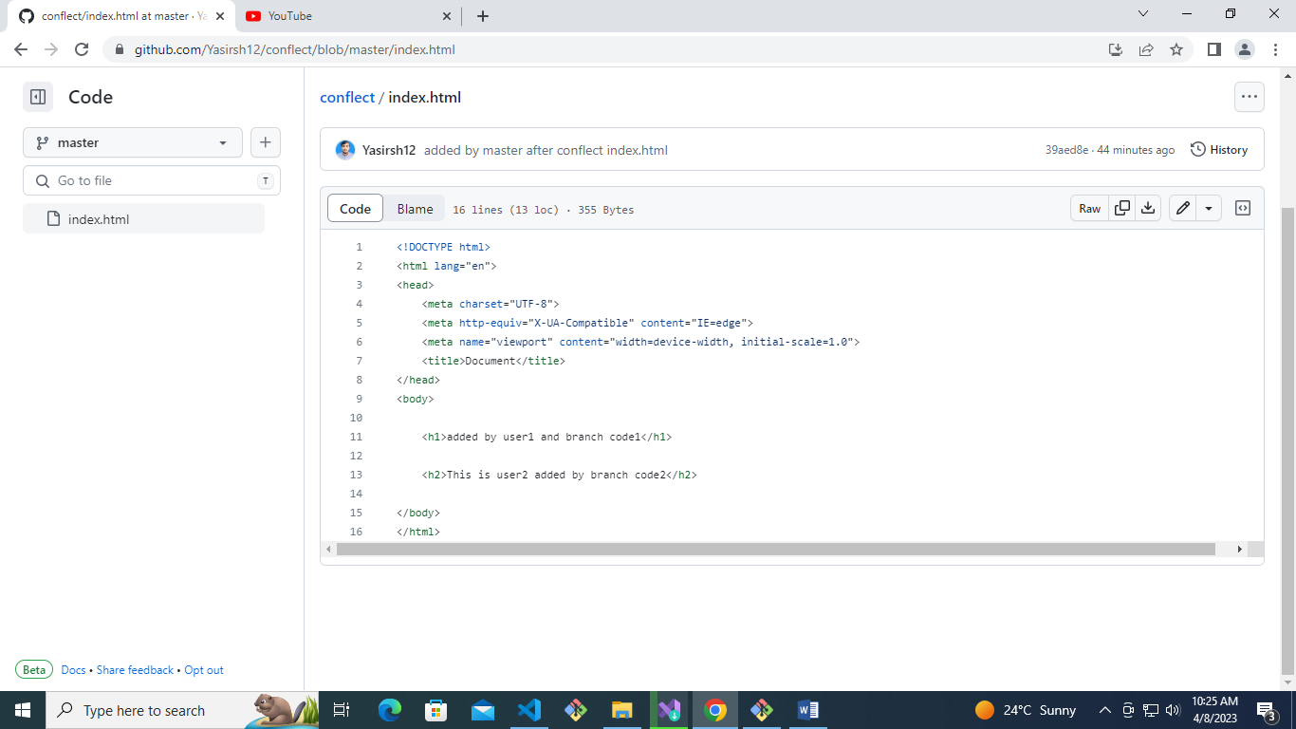

int age = 24;

string name = "Yasir";

string address = "Karak kpk Pakistan";

string birth = "17/01/1998";

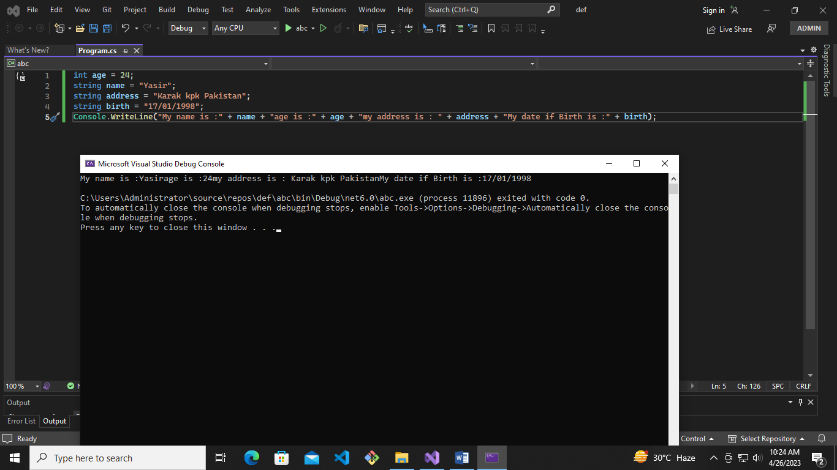Console.WriteLine("My name is :" + name + "age is :" + age + "my address is : " + address + "My date if Birth is :" + birth);

**Date : 11/04/2023**

Console.WriteLine("This is Arithmetic operator");

Console.WriteLine("Yasir Shahzad");

Console.WriteLine(10 + 12 * 100 / 20);

Console.WriteLine("This is Arithmetic operator");

Console.WriteLine("Yasir Shahzad");

Console.WriteLine(100 + 120 * 1100 / 220);

Console.WriteLine("This is Arithmetic operator");

Console.WriteLine("Yasir Shahzad ");

Console.WriteLine(210 + 212 * 100 / 320);

Console.WriteLine("This is Arithmetic operator");

Console.WriteLine("Yasir Shahzad");

Console.WriteLine(104 + 124 * 1020 / 204);

Console.WriteLine("This is Arithmetic operator");

Console.WriteLine("Yasir Shahzad");

Console.WriteLine(104 + 142 * 100 / 203);

Console.WriteLine("This is Arithmetic operator");

Console.WriteLine("Yasir Shahzad");

Console.WriteLine(110 + 122 * 100 / 20);

Console.ReadLine();

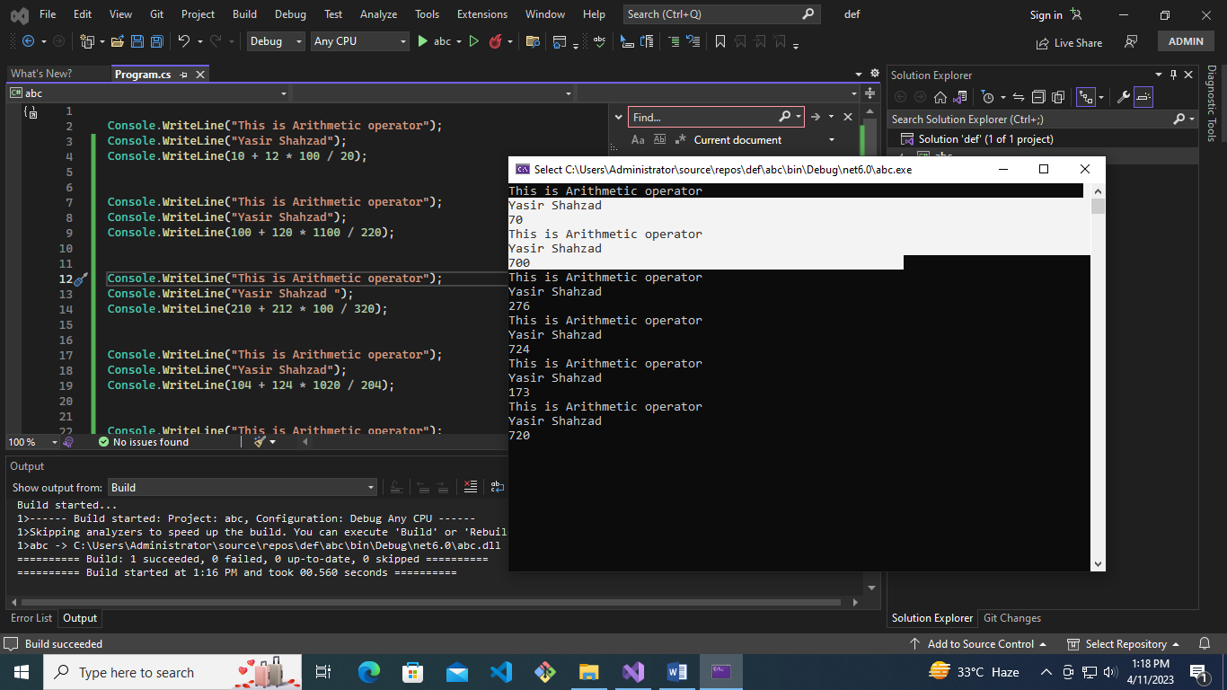

Console.WriteLine(20 > 10 && 10 > 5 || 55 > 65 && 60 > 10);

Console.ReadLine ();

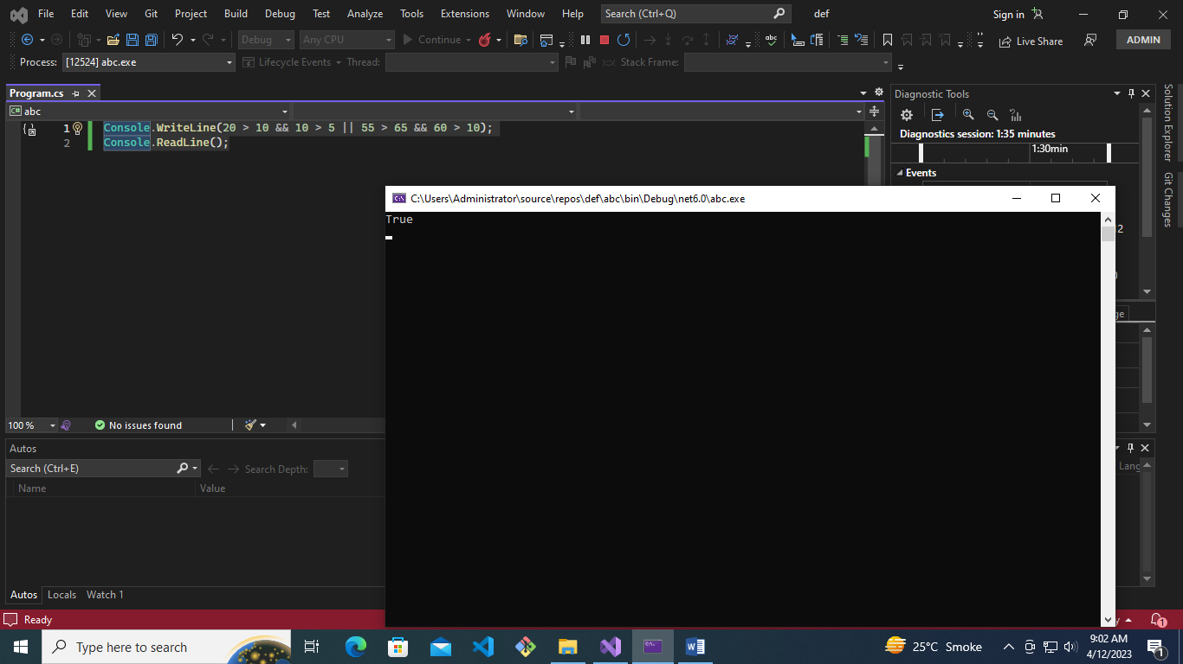

Console.WriteLine(4 | 3);

Console.WriteLine(4 & 3);

Console.WriteLine(14 | 13);

Console.WriteLine(14 & 13);

Console.ReadLine();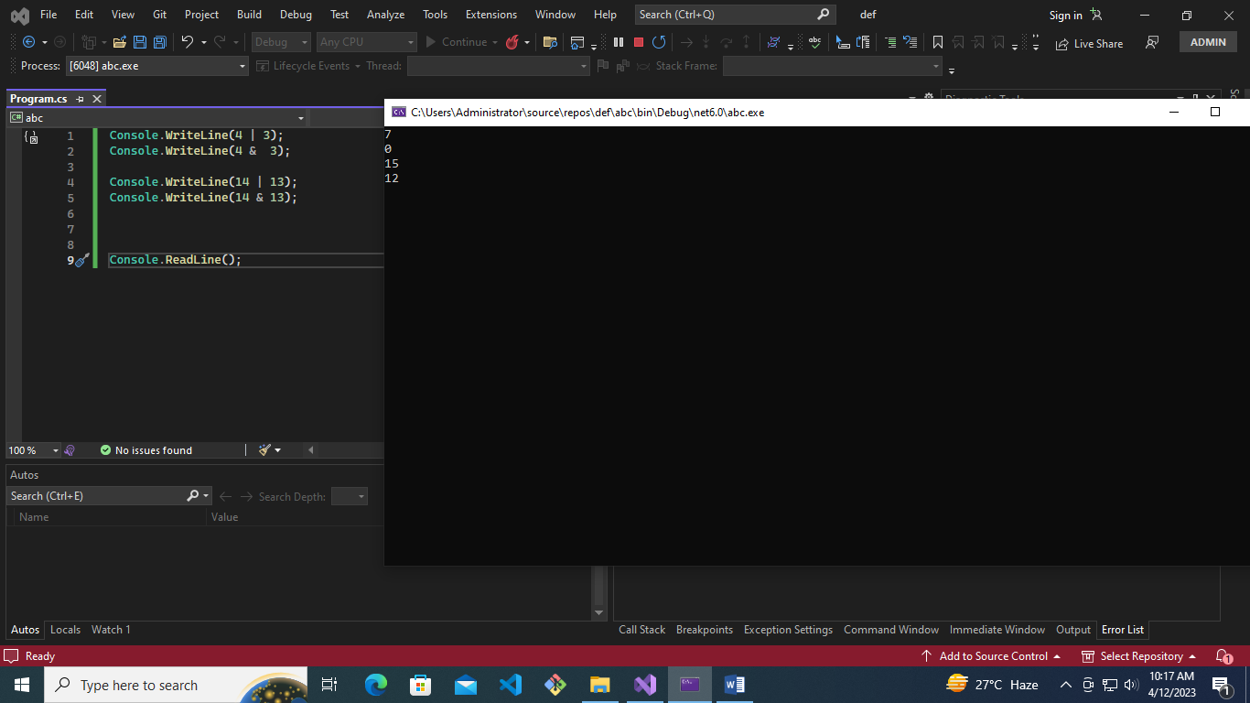

**Date : 12/04/2023**

Console.WriteLine(4 | 3);

Console.WriteLine(4 & 3);

Console.WriteLine(14 | 13);

Console.WriteLine(14 & 13);

Console.WriteLine("i love pakistan");

Console.WriteLine("i love \n pakistan");

Console.WriteLine("i love \\\\ pakistan");

float price = 505.444444f;

Double frq = 505.444;

char key = 'F';

string firstName = "Alia"; //camel case

string lastName = "Butt"; //camel case

bool isOk = true; // it is boolean value true or false

int sugarPrice = 110;

const string collageName = "Shaheen collage"; //We declare constant value. and constant value can't be changed

Console.WriteLine(price);

Console.WriteLine(frq);

Console.WriteLine(key);

Console.WriteLine(firstName + " "+ lastName); //string concatination

Console.WriteLine(isOk);

Console.WriteLine("this is sugar price="+ sugarPrice);

Console.WriteLine(collageName);

Console.ReadLine();

